Overview

Willamette DC Transceiver

Winter 2008 qrp-l.org Group Project

Design by Jason Milldrum, NT7S

A Quick Geography Lesson
Recently, I've acquired the habit of naming my transceiver projects after the waterways in my native northwest Oregon. I've christened this project after the Willamette River, the waterway which runs through the most populous portion of the state. The name is pronounced wil-LA-met, with the stress on the middle syllable, which isn't usually obvious to non-natives. An Oregonian can tell that someone isn't from around here when they pronounce the name willa-met.
The Willamette River is a large tributary of the mighty Columbia River, but is navigable only a small portion of the way from its confluence with the Columbia. The head of navigation is at Willamette Falls in Oregon City, which is only 26 miles upstream from the confluence. However, the river spans a total length of 187 miles. The name seemed fitting since the Willamette River is the waterway which binds together a large portion of the people in our state. In the same way, I hope that this project can help to bring together a portion of the QRP community in the spirit of experimentation, learning, and fellowship.

Theory of Operation
The Willamette Transceiver features a heterodyne VFO, which provides a local oscillator signal for a direct conversion receiver and a QRP transmitter. Refer to Illustration 1 for a complete block diagram of the radio.
On the receiver side, incoming RF is first fed into a preselector, which is a simple tuned circuit designed to prevent strong out-of-band signals from overloading the receiver front end. This helps to preserve the dynamic range of the receiver. Following the preselector is a RF preamplifier of modest gain. The preamp helps to overcome the noise present on the higher HF bands, but serves a more important purpose in this receiver. The grounded-gate amplifier configuration has very good reverse signal isolation. This protects the front end from the LO leaking out of the product detector and being reflected back into it from a poor antenna match. Next, the incoming RF is more aggressively filtered by a double-tuned circuit before being applied to the RF port of a standard double-balance diode ring mixer. The incoming signals are mixed with the heterodyne VFO signal to convert them down to audio frequencies. A diplexer is placed on the output port of the mixer to terminate unwanted mixing products in 50 Ω. The very weak audio frequencies are next filtered through a few active low-pass stages and then preamplified, before heading into the volume and mute circuitry. Finally, the desired AF signal is amplified to headphone volume with a class-A audio amplifier, followed by a class-AB audio power amplifier which can drive a low impedance load.
The transmitter chain of the transceiver is very simple. A CW signal is generated directly on the desired transmit frequency by the heterodyne VFO. Since it is already on frequency, the only thing that we need to do to it is to amplify it to the desired output power and provided keying circuity. The VFO output of approximately +9 dBm is fed into a class-A broadband driver amplifier which boosts the signal approximately +25 dBm (330 mW). A potentiometer on the input of the driver amplifier allows the transmitter drive level to be adjusted all of the way to 0 watts. The output of the driver amplifier is fed to a simple class-C power amplifier, which brings the CW signal to a final output power of about +37 dBm (5 W). Since class-C amplifiers are non-linear, they produce an output rich in harmonics. In order to be courteous to fellow operators and meet FCC specifications, a low-pass filter is placed on the output of the power amplifier. A classic solid-state T/R circuit is connected to the low-pass filter to provide a signal path for the receiver.
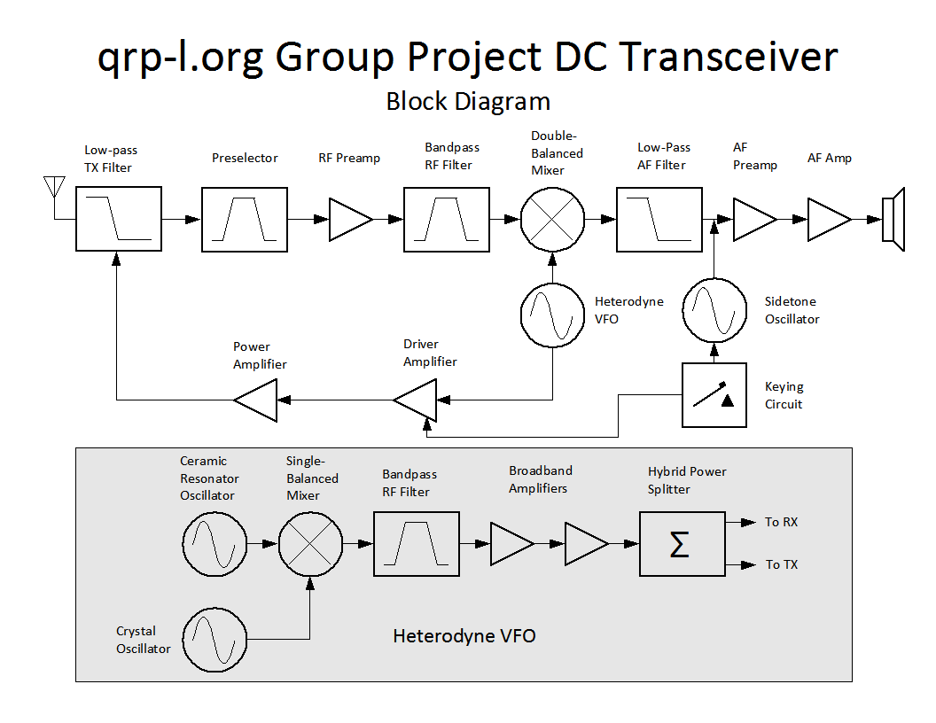Illustration 1: Transceiver Block Diagram
Because we want to use a direct conversion receiver scheme on the upper HF bands, a simple VFO is not feasible due to stability problems. VXO control often leaves much to be desired due to the limited and non-linear tuning range. In order to overcome these obstacles, a heterodyne VFO design is used in this rig. Two different oscillators are used, a ceramic resonator oscillator and a crystal oscillator. The two signals are mixed to produce a LO signal on the desired amateur frequencies. The lower frequency ceramic resonator oscillator provides a fairly large tuning range, while having increased stability over a VFO. The higher frequency crystal oscillator provides a very stable CW note to mix to. It also allows a fixed amount of transmit and RIT offset regardless of where the VFO is tuned to, something that a single VXO or ceramic resonator oscillator does not allow. The two signals are mixed in a single-balanced diode mixer, then filtered through a double-tuned circuit. Because of losses in the mixer and filter, two broadband class-A amplifiers are used to bring the LO signal up to a usable level. Finally, a 3 dB hybrid splitter is used to provide two different outputs for receiver and transmitter use.

Sanity Checks
In order to maximize your success in building any radio of moderate or high complexity, it is best to test each stage of the radio as you build. These verification steps will be called sanity checks in this document. By performing these sanity checks after building each section, you can proceed with your build with the knowledge that all of your completed circuitry is working correctly. Not only does this build your confidence, but it makes it much easier to troubleshoot problems if they do crop up. A great example of this method is given in the article “Building Kits to Learn”, found in the November 2007 issue of QST. A copy of this article (available to both members and non-members) can be found on the ARRL website (http://www.arrl.org/qst/2007/11/mitchell.pdf).

Caution: Be sure to remove power from any circuits under test when you are finished making measurements, before you start building again!

Margins
Many of the sanity checks will have specific measurements to check against. While it is nice to confirm a measurement that is the same as the build document, it's rare that you will actually see this. Due to variations in test equipment, power supplies, build methods, and components, your readings will be a bit different from the measurements noted here. Generally speaking, as long as your readings are within approximately 5% of the measurements listed here, your circuit is operating correctly. In some cases, you might be fine with variations of up to 10% (or more). If you are uncertain if your measurement indicates a correctly operating circuit, contact an Elmer for some advice. You are also welcome to contact me, see my website (www.nt7s.com) for details.

Preparation

Required Tools and Equipment
This list represents the bare minimum tools and equipment that you must have available in order to complete this project.
- Digital Multimeter or VOM
Perhaps the single most important piece of test gear that a homebrewer can own. Even a cheap meter, such as those found on sale at Harbor Freight, will be good enough for our purposes.
- RF Probe
This is not necessary if you have an oscilloscope, but it's still nice to have for quick measurements of RF power. If you don't currently have a RF probe, you can easily build one using instructions found at the end of the documentation.
- General Coverage HF Receiver
A rig with digital frequency indication to 10 Hz resolution is highly recommended.
- +12 VDC Power Supply, 1 A minimum
The completed transceiver draws about 850 mA on transmit, so a 1 A power supply would be the bare minimum. Current limiting is a definite bonus when homebrewing projects. An alternative would be a 12V battery (like a gel cell), although this is riskier since there is no overcurrent protection.
- 50 Ω Dummy Load (minimum 5 W capacity)
You can use anything from a commercial 1.5 kW dummy load to four 2 watt, 200 Ω resistors in parallel. Most of the circuit blocks in the transceiver are designed to be terminated in 50 Ω, so when testing virtually everything but the last two transmitter stages, you can just tack a 51 Ω resistor from the output of the circuit to ground to terminate it properly.
- Soldering Iron
A good quality, temperature controlled iron is important for trouble-free construction of this project (or any other significant project).
- Needle-nose Pliers
Just about any pair of small needle-nose pliers will do, although your life will be easier if you use a high-quality pair.
- Diagonal or Flush Cutters
As with the pliers, almost any cutters will do for type of building, but you'll never regret owning a high-quality tool.
- Hobby Knife
A good, sharp hobby knife (such as an X-acto) is necessary for scraping the enamel off of magnet wire, as well as for other cutting tasks.

Optional Tools and Equipment
Any tools or equipment listed below is optional for the construction of this project, although many will make your life much easier if you have to do any troubleshooting.
- Frequency Counter
Very useful for verifying the proper operation of the heterodyne VFO.
- Oscilloscope
Although this is listed as optional equipment, the usefulness of an oscilloscope cannot be overstated. A bandwidth of 60 MHz is probably the minimum for accurate voltage measurement, but even a 20 MHz scope will provide very useful qualitative information about the signals in your transceiver.
- Signal Generator
A signal generator capable of providing a sine wave output in the HF spectrum is handy for injecting signals into the transceiver for tasks such as checking the receiver signal path and sweeping filters.
- Power Meter
Insuring that the proper signal levels are present in the transceiver is very important. These can be measured using a oscilloscope and 50 Ω termination, but it is much easier and quicker to use a power meter with a scale calibrated in dBm. Good examples for the homebrewer are the W7ZOI meter or the M³ Electronix FPM-1 kit.
- Audio Oscillator
An audio oscillator of some kind is handy for checking the correct operation of audio amplifier and filter stages. Even if you don't have a commercial model, you can build the transceiver's Twin-T sidetone oscillator for use in verification and troubleshooting.
- Noise Generator
A broadband noise generator can be useful for quickly checking that a receiver is operating correctly, as well as for measuring filter shapes if you have the correct test equipment.

Parts Inventory
Please do yourself a favor and take a few moments to inventory the parts in your kit before you get started. This will help you to organize the parts when it's time to build, as well as let you know if you are missing anything. If anything is missing or incorrect, please contact NT7S for an immediate replacement.

Manhattan Construction Methods
The Willamette Transceiver can be built using any method of RF construction that you prefer, however this tutorial will focus on the Manhattan method which is popular in the QRP homebrewing community. I won't go into great detail about Manhattan construction since there are many excellent tutorials already published on the Internet. If you are new to the method, I recommend that you study some of these detailed tutorials, then come back to this document for specific instructions for this project.

Pads
In Manhattan construction, pads of punched out copper clad material are used as circuit nodes and as mechanical anchors for the components. The pads are glued to the copper clad substrate with a cyanoacrylate glue (known as Superglue or Krazy Glue to most folks). I like to buy 3-packs of the gel-type Superglue from the local dollar store for my circuit construction.
Builders use various shapes and sizes of pads based on their personal preferences and the needs of the circuit. In nearly all of my work, I have standardized on a 5 mm diameter circular pad. I've found that it is a very flexible size to use when working with through-hole components. The standard build instructions for the Willamette uses 5 mm pads throughout the entire rig. Usually, one pad will be sufficient for a circuit node, but there are times when too many connections need to be made to a single node to fit on one 5 mm pad. In these cases, you will find that another pad is glued nearby and is jumpered to the other pad with a small piece of excess component lead.
You can use various methods for locating and placing the pads based on your familiarity with Manhattan construction and your preferences. In working with a beta version of the rig, I found that it works well to print out a copy of circuit layout diagram for measurement purposes. When printed without any scaling, you should have a 1:1 scale diagram of the circuit. When you proceed to place the first component in a circuit section, measure the distance of one of the component pads from the nearest edges of the board on the layout diagram. If your copper clad is cut to the same dimensions as the board outline on the diagram, you can use this measurement to locate the actual pad placement. Use a marker (such as a fine-point Sharpie) to mark this location. Next, place a small bead of Superglue on this point and glue down the pad. When you place the subsequent pads, measure their locations relative to a pad that you previously placed in this circuit section. Keep proceeding in this fashion to complete the circuit section.
There is a bit of wiggle room when building a Manhattan circuit, so don't worry too much about getting the measurements exactly right. If you feel that you don't quite have the room that you need to locate a pad, you have a few different options. First of all, don't be afraid to locate a pad a little closer to others if necessary, as long as they aren't physically touching each other to create a short. You probably won't get a perfect match to the layout diagram, but you should be able to place things fairly close. Sometimes you can also leave extra lead length or shorten the lead length on components to get them to fit it tight spaces. The large 5 mm pads give you quite a bit of margin of error in placing the components. If it looks like you really can't fit a pad into the area it's supposed to go into, you can always use a smaller pad. It may be easiest to just cut the pad in half using some cutters. In most cases, you can still place components to a smaller pad just fine, unless you have a node with many connections. If all else fails, you can also unsolder some components and remove the pads you've placed in the circuit section. If you have to resort to this, I recommend that you grasp the pad with needle-nose pliers and twist the pad to break the bond with the copper clad. The truth is that there is no “correct” way to wire a Manhattan circuit, as long as it is electrically sound. Use your judgment and a little creativity, and all will be well.

Resistors and Molded Inductors
To begin forming resistors (and other similar components) for installation, first put a 90° bend in one of the leads.
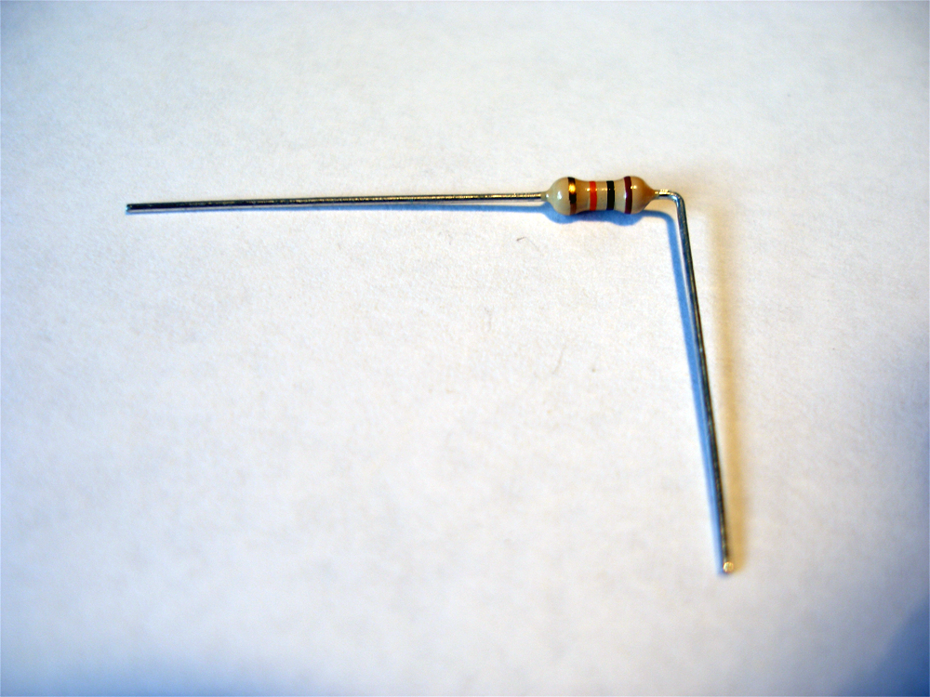
Next, place another 90° bend in the same lead just a little bit further away from the body, so that the lead bends back in the direction of the other lead.
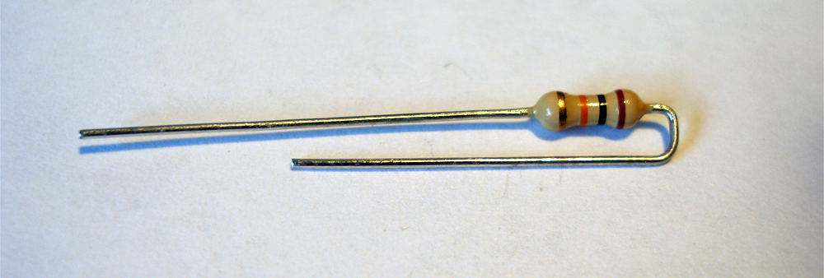
Now bend the other lead 90° away from the first lead.
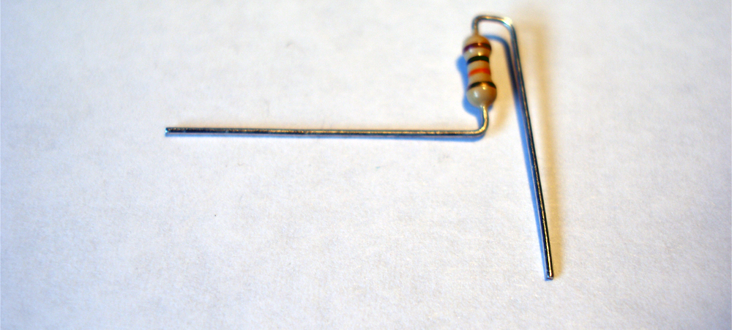
Put one more 90° bend in the first lead, so that the remaining length is aligned with the second lead, pointing 180° away. If this component has one terminal which connects to ground, then leave one lead slightly higher than the other to allow for the difference in height between the pad and the ground plane.
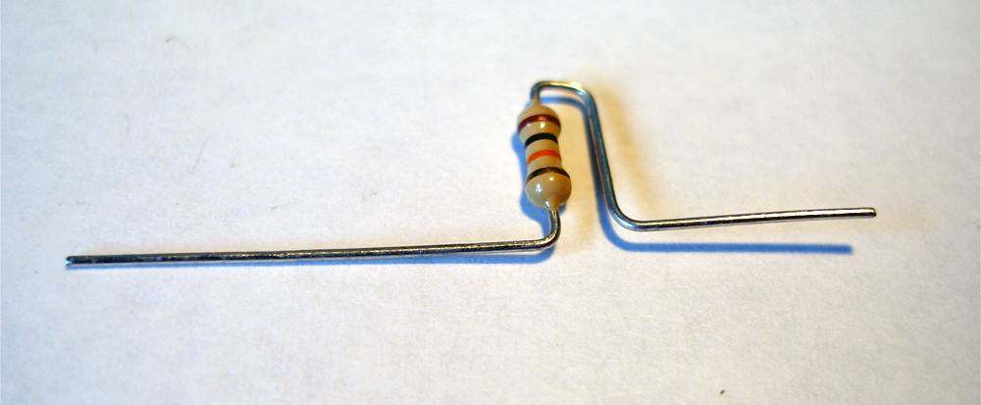
Trim the excess lead length from both leads.
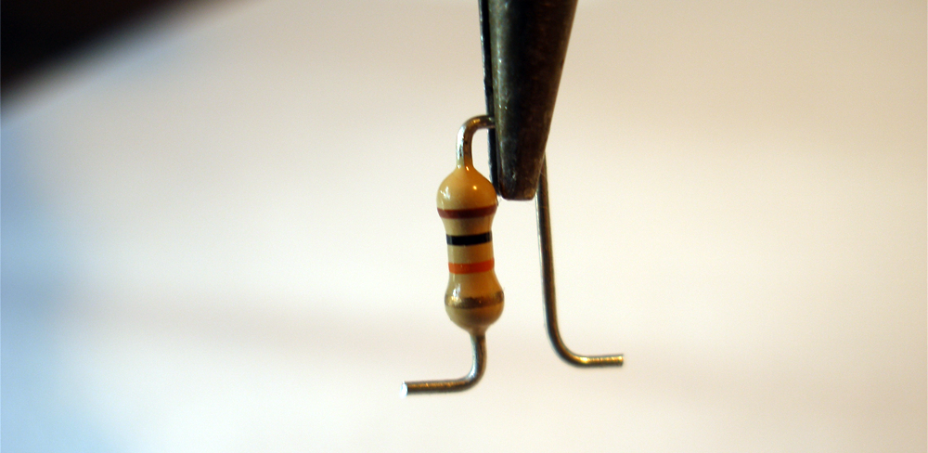

Capacitors
Capacitors are easy to prepare for installation. If you are installing monolithic 10 nF or 100 nF capacitors, you may have to straighten the leads before doing anything else. Many of the ceramic capacitors already have straight leads.
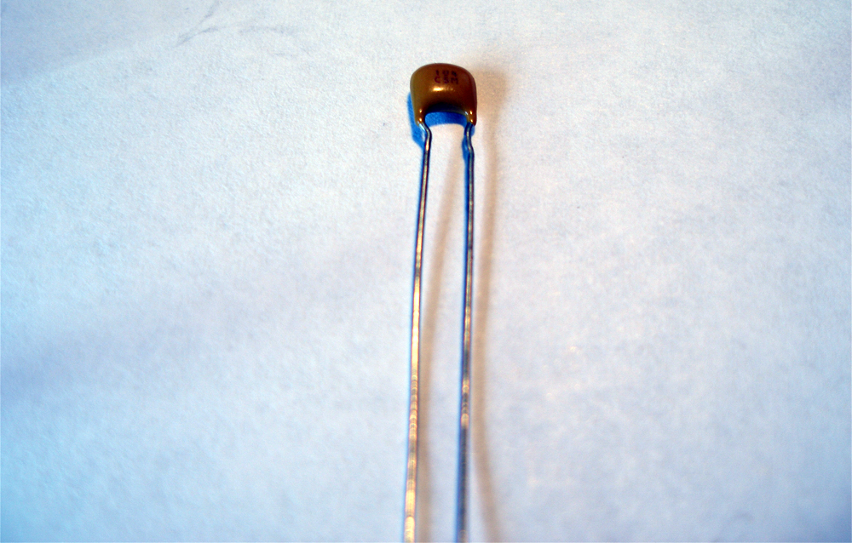
Place a 90° bend in each of the leads, pointing away from the body of the capacitor.
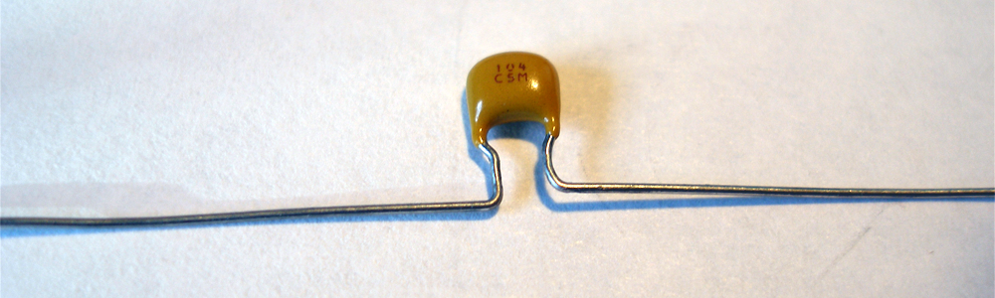
Clip the excess lead length to complete the preparation.
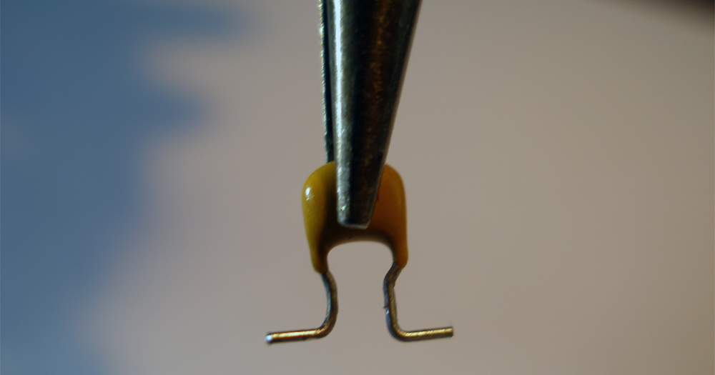

Diodes
Diodes are formed in a similar fashion to resistors, but with one important difference. Since they are polarized, you need to take care to differentiate the two terminals of the device. Follow the layout diagram to determine where the anode and cathode terminals go in each instance.
First, bend the anode lead (the one on the end which does not have the black stripe) so that it wraps around 180° as shown.
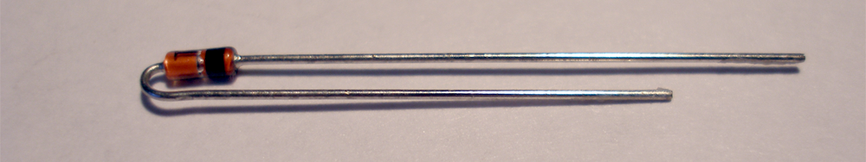
Place 90° bends in each of the two leads so that they point away from each other.
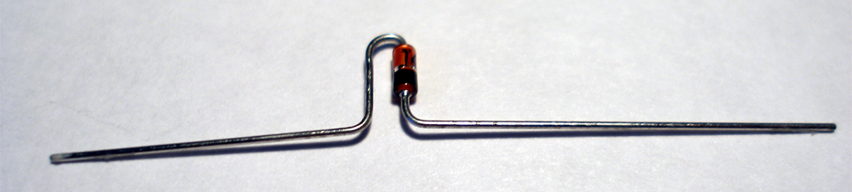
Finally, clip the ends of the leads so that the diode can be placed on the copper clad. Note that in the audio amplifier, you will have to form the diodes so that they lay flat instead of standing up.
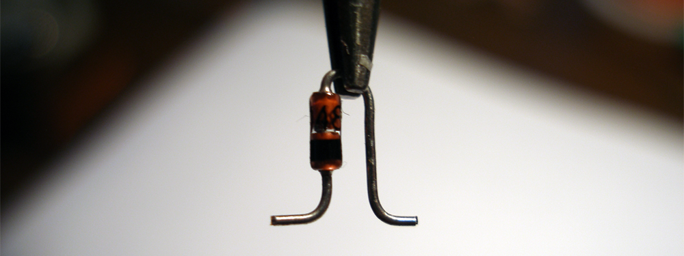

Toroidal Inductors
The first step in preparing a toroid for installation is to cut some magnet wire to the length specified in the build instructions. If you really want to play it safe (such as if you've never wound toroids before), you might want to cut off an extra inch or two to give yourself a safety margin. It's a bit more painful to unwind the toroid when you run out of wire than it is to clip off some excess.
Put the first turn on the toroid by inserting the wire through the center of the core. Leave about 1 inch of wire on one side of the core, then form the wire so that it wraps firmly around the outside of the core. Take the long end of the wire and place it again through the center of the core, in the same direction as the first turn. Pull the wire through the core and snug it up against the toroid body. Be careful when snugging the wire that you don't scrape off the wire enamel, which could give you an unexpected short.
Continue wrapping the wire in this way until you get the desired number of turns. Do not cross the wire over itself during the winding. Remember that each passing of the wire through the center of the core counts as one turn, so the initial placement of the wire is counted as your first turn. Trim off any excess wire length so that both leads are around an inch long. Ideally, there should be about 30° of the toroid not wrapped with wire, so you may need to expand or compress the turns to get the desired coverage of the core. The picture below shows the amount of wire coverage you want on a core.
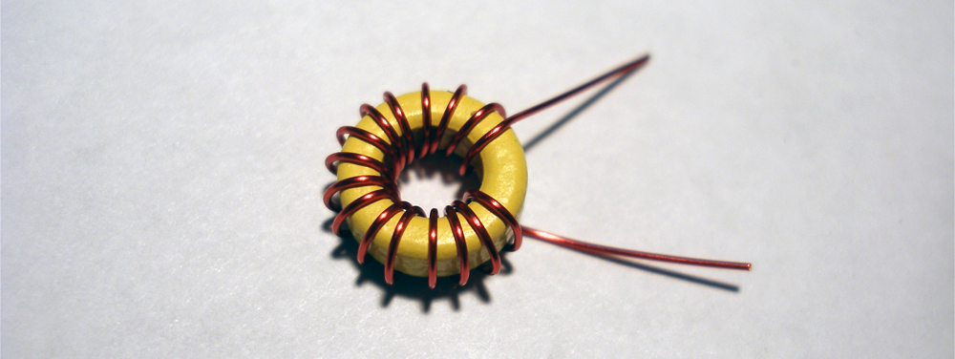
Using your hobby knife, carefully scrape the enamel from the ends of the two toroid leads. Be very careful not to nick the magnet wire when doing this, as this will weaken the wire and could lead to a future wire break. Place a 90° bend in each of the two leads so that they point away from each other. Trim off the excess lead length so that only about 1/8” remains after the bend. Finally, tin the leads using a blob of solder on your soldering tip. You may need to hold the lead in the solder blob for a while to burn off any excess enamel which might remain on the wire.
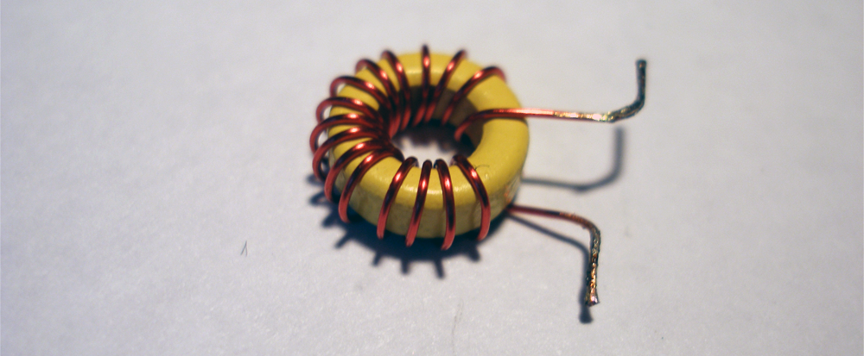

Toroidal Transformers (Step-Down)
The first step in preparing the step-down transformer is to place the primary winding on the core in the same way that you would prepare a regular toroidal inductor.
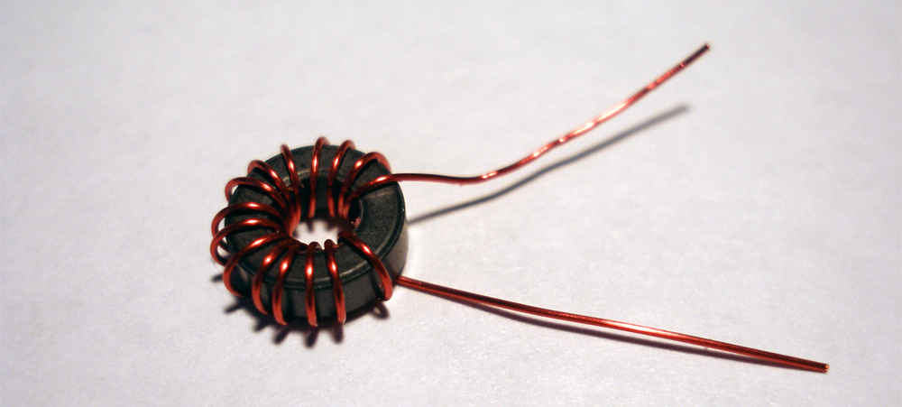
Next, the secondary winding is placed on the core. Start by inserting the wire for the first turn in the same direction as the primary winding, but beginning on the opposite side of the core.
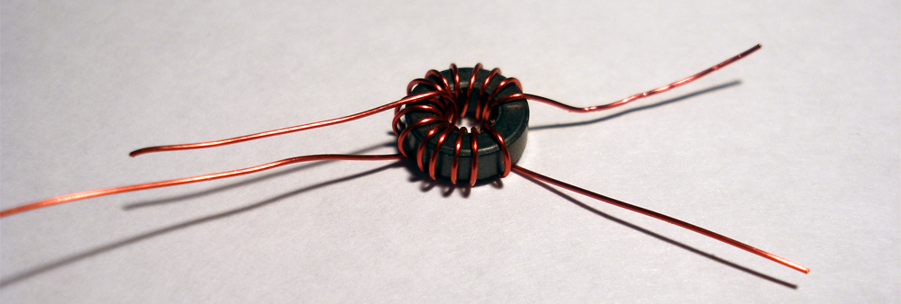
Wrap the required number of secondary turns in the same direction as the primary. When the transformer is complete, you should have the ends of the primary and secondary windings on approximately opposite ends of the core. Trim and tin the leads as shown in the instructions for toroidal inductors.
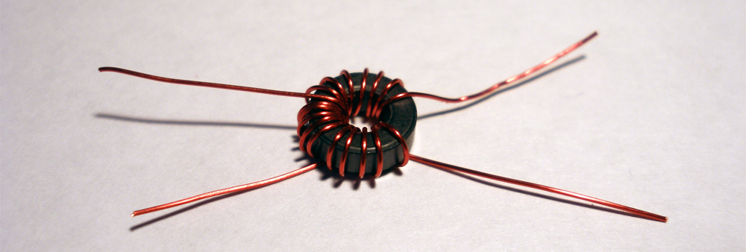

Toroidal Transformers (Bifilar and Trifilar)
Preparing bifilar and trifilar transformers are a little more involved than simple toroid inductors, but they are nothing to be scared of. The first task when constructing one of these transformers is to prepare the wires. The wires need to be twisted together, then they can be wound around the toroid core as a single bundle. If you are making a bifilar transformer, you'll need two separate wires. A trifilar transformer needs three wires. Building the transformer is easier if you use separate colors for each of the wires, although it's not strictly necessary. You can also use your multimeter as a continuity checker to identify each individual wire.
Gather together a 10” length of each wire needed for the transformer. There's a few different ways you can go about twisting the wires. The easiest that I have found involves a vice and handheld drill. Place the wires parallel to each other, so that the ends are flush. Place one end of the bundle in the vice and secure it. Place the other end of the bundle in the chuck of your drill, then pull the drill away from the vice so that there is tension on the wire bundle. You can now use the drill to place a nice, uniform twist into the wire bundle. I like to shoot for about 6 turns per inch, but this is not very critical. You can also twisted together wire manually, but this is much harder and more time consuming.
Now you can wind your wire bundle as you would a toroid inductor. Every bifilar transformer in this project (except for the one on the PA output) has 10 turns wrapped around a FT37-43 core.
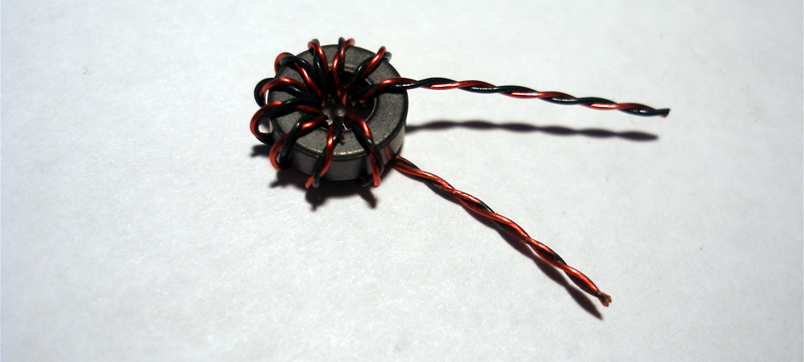
Once the bundle is wrapped around the core, separate the individual wires from each end. If you used different colors (in this example, red and green), then you'll have two wire colors on each end. Now, the opposite wires from each end will need to be connected together to form the tap point. In this example, this means that the green wire from one pair of lead ends is connected to the red wire from the other pair of lead ends. Strip the enamel from each of these wires, then wrap one of the wires tightly around the other, as shown below.
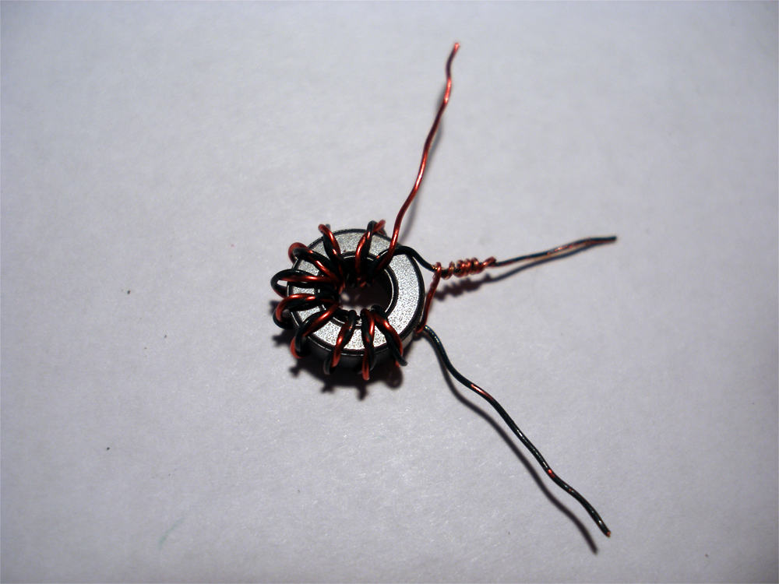
Solder together the wrapped wire to create the tap lead. Next, strip and tin the remaining leads to complete the bifilar transformer.
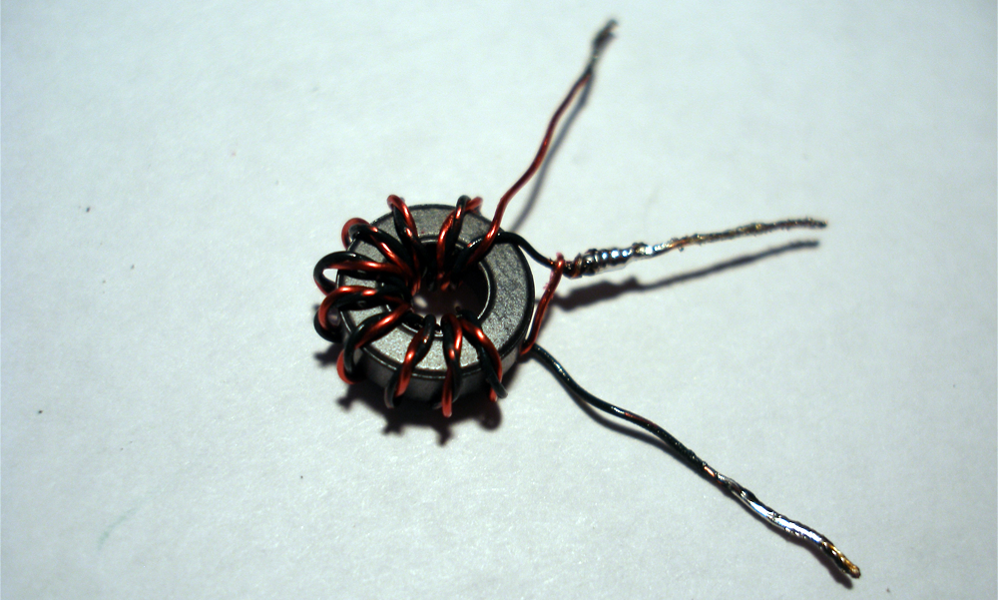
A trifilar transformer is constructed similarly. Wind the bundle of three wires around the core as specified.
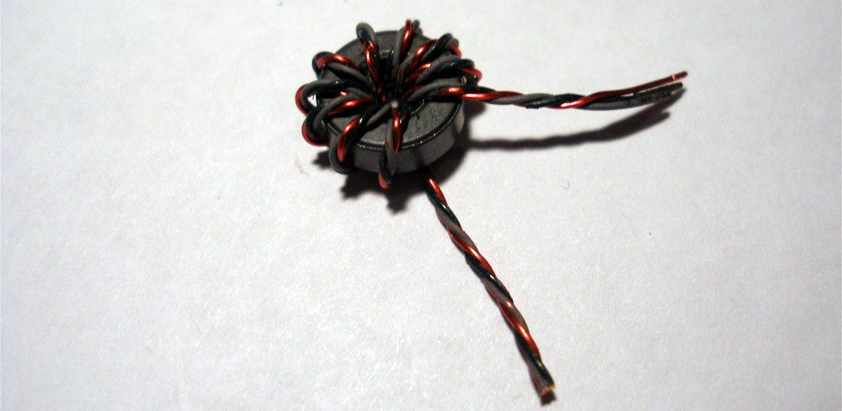
Separate the individual wires on each lead end.
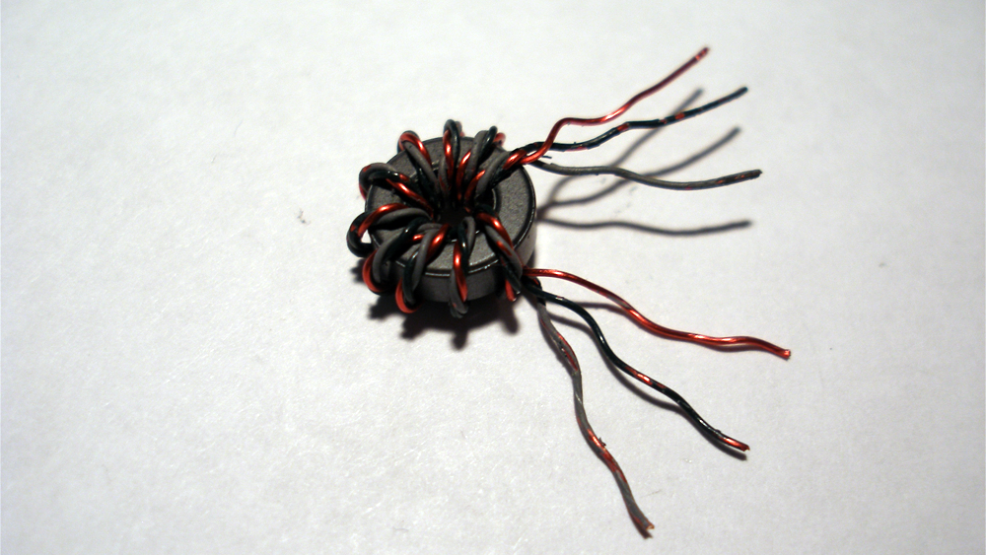
Two of the different wires from each lead end are connected together to form a tap point (red and green in this example).
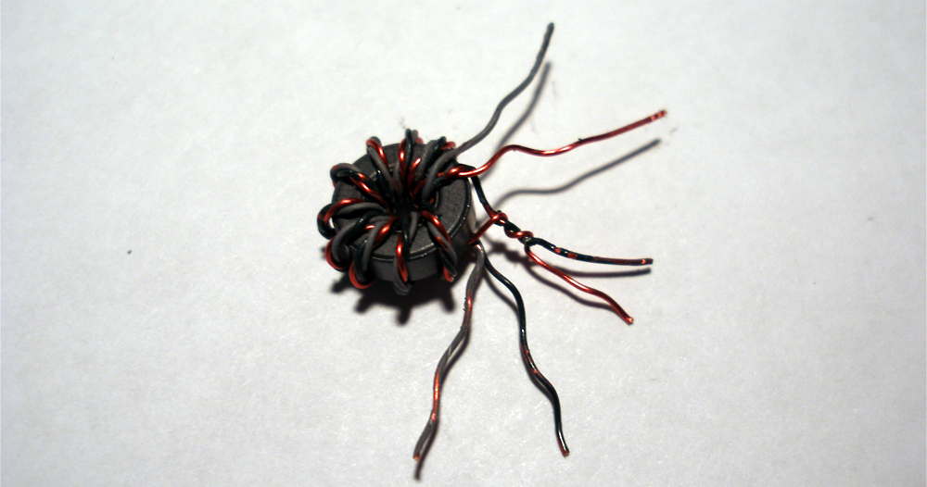
The remaining wire (grey in this example) is left alone. It is used as the input link when this transformer is used in a diode mixer.
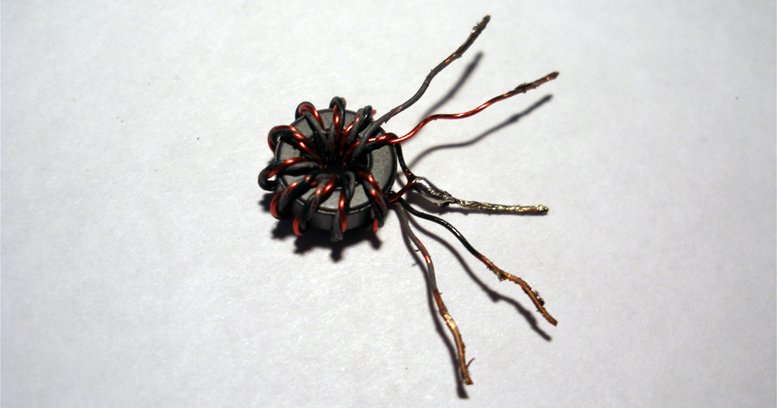

Binocular Core Transformer (Bifilar)
The bifilar binocular core transformer used in the transmitter power amplifier really just about the same as the bifilar toroidal transformers used in the rest of the rig. The only difference is how you wind the wire bundle around the core. Looping the bundle through one hole, then back down through the other counts as one turn. The picture below demonstrates the first turn of the binocular transformer.
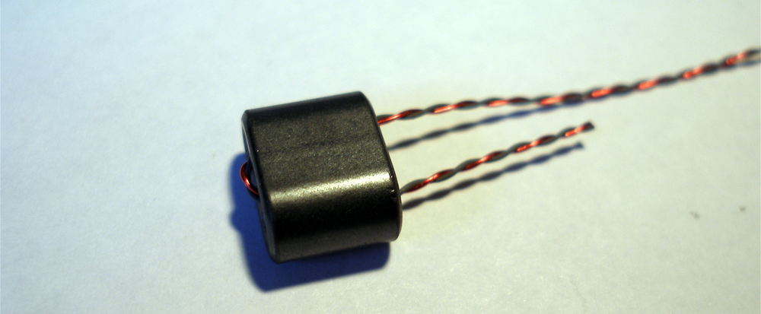
Wrap 5 turns around the core in total.
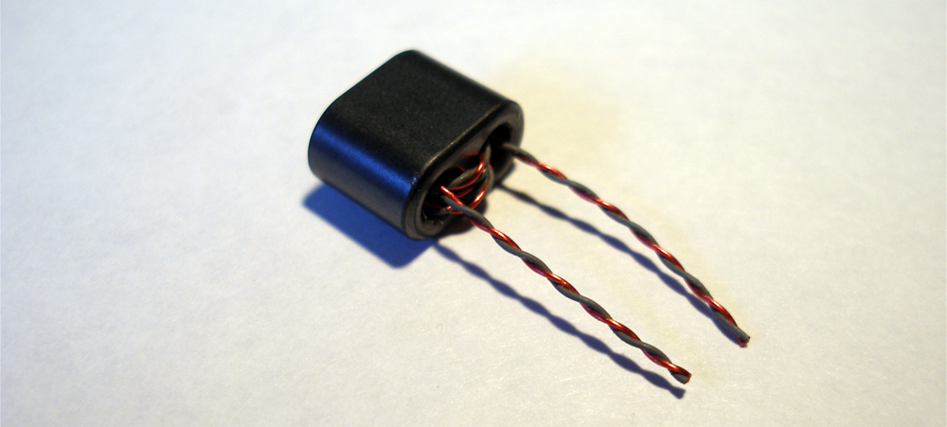
Separate the individual wires.
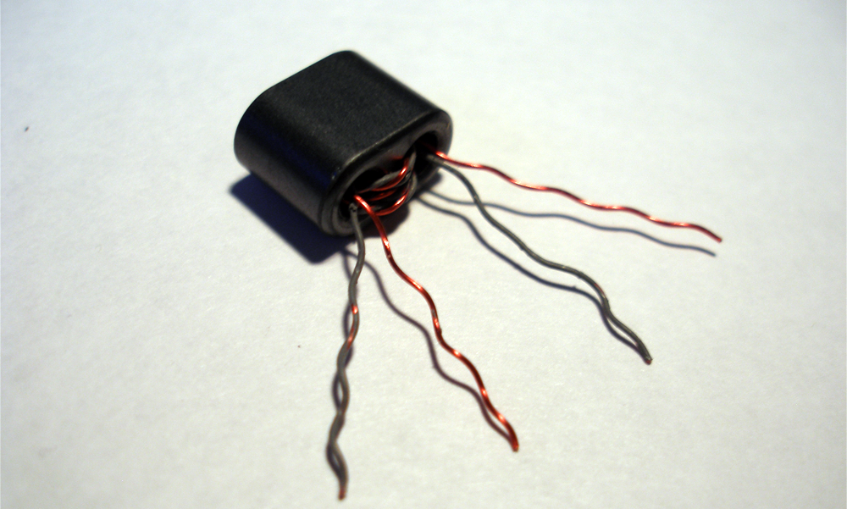
Solder together the two opposite wires to form the tap point.

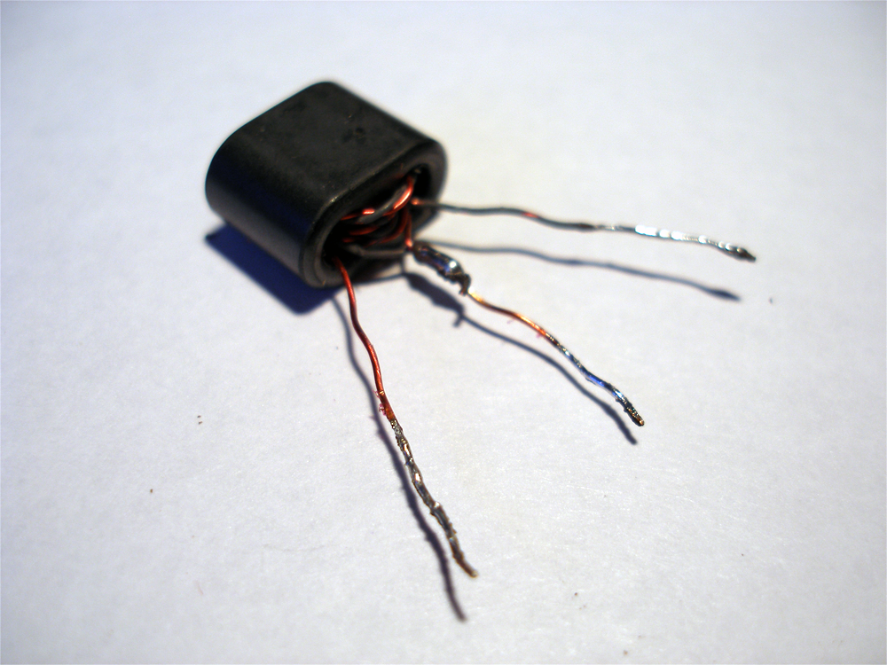
TO-92 Devices (Transistors and Voltage Regulator)
Begin by forming a 90° bend in one of the outside leads, so that it points away from the other leads.
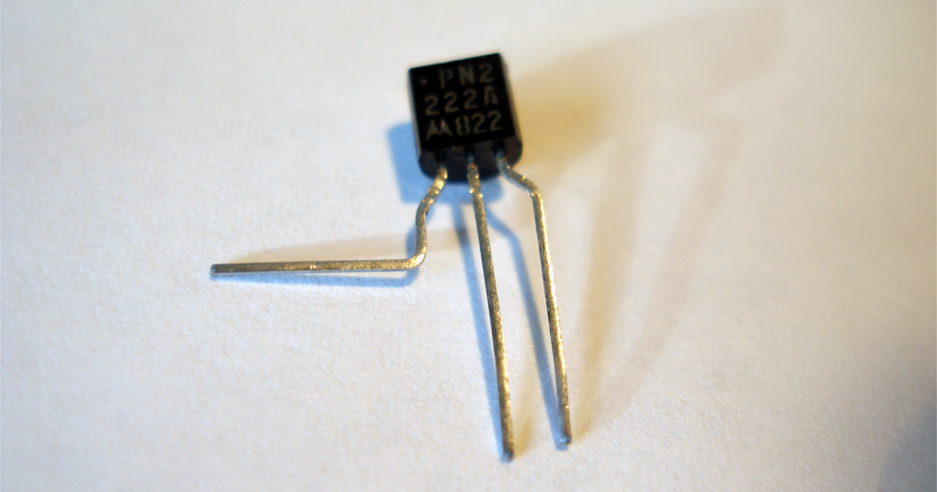
Form a 90° bend in the other outside lead, in the opposite direction from the first bend.
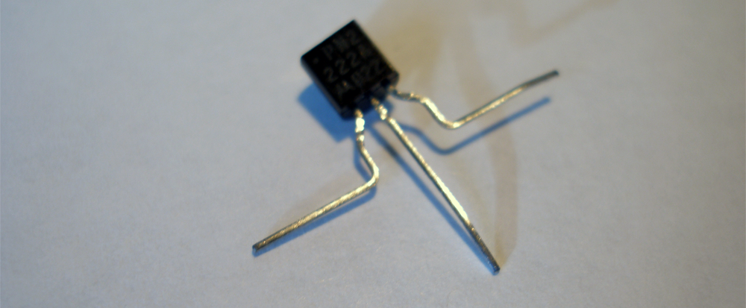
The middle lead will have to be bent near the package at a 45° angle, either towards or away from the flat side of the device. Check the layout diagram to see which way each particular device is configured. Place another 45° bend in the same lead at the same level as the other two bends so that it will sit flat as shown below.
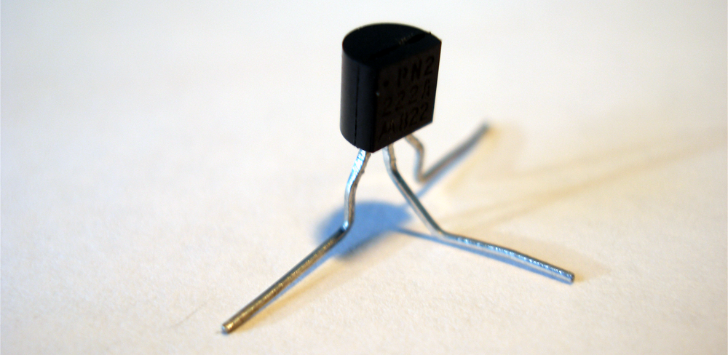
Finally, clip the excess lead length.
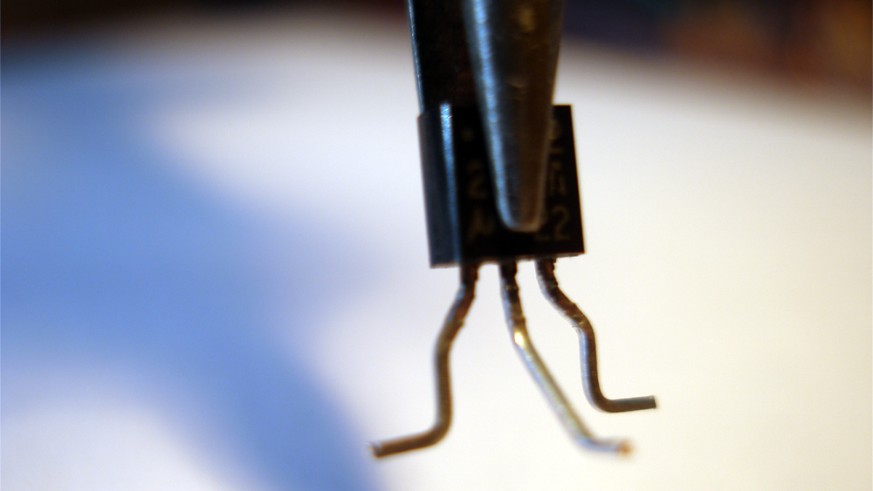

TO-220 Transistors
The PA transistor is in a plastic TO-220 case (it's actually called a TO-220D). When looking at the case in the orientation where you can read the markings, the leads from left to right are base, collector, and emitter. We need to form the base and collector leads to go to pads, while the emitter lead goes to ground. The case will lay flat on the copper clad in the way shown below. Place a 90° bend in the base lead and then bend the end of the lead down a bit to reach the level of the pad. The collector lead just needs to be bent down slightly to also reach the level of the pad. The emitter lead can be bent down to the level of the ground plane, then bent 90° to provide a convenient solder point.
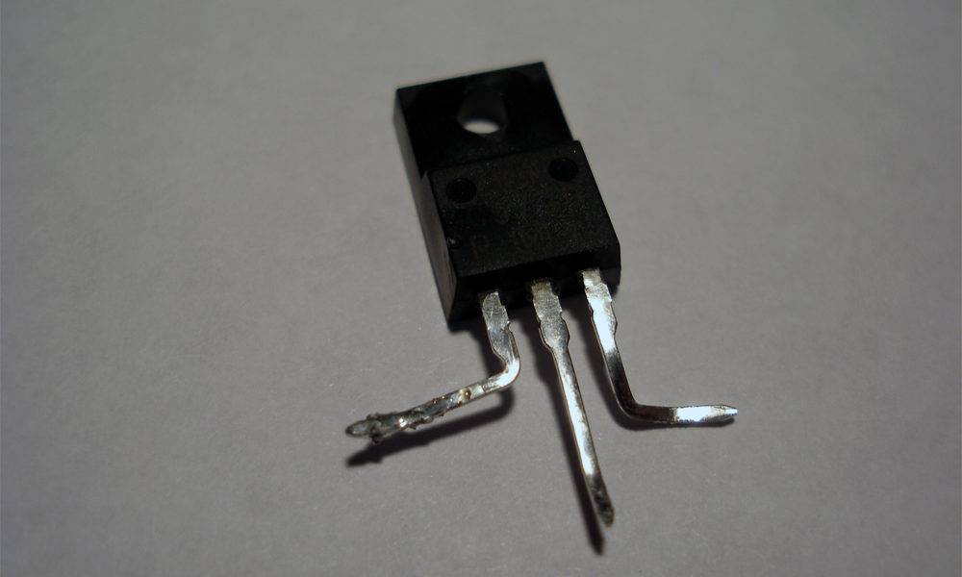

Crystals and Other Devices
You will have a few miscellaneous two-terminal devices to install, such as a crystal and ceramic resonator. These are very easy to prepare. Just bend the leads 90° away from the body in the way shown below. If you are unsure of the way the leads are formed, consult the layout diagram.
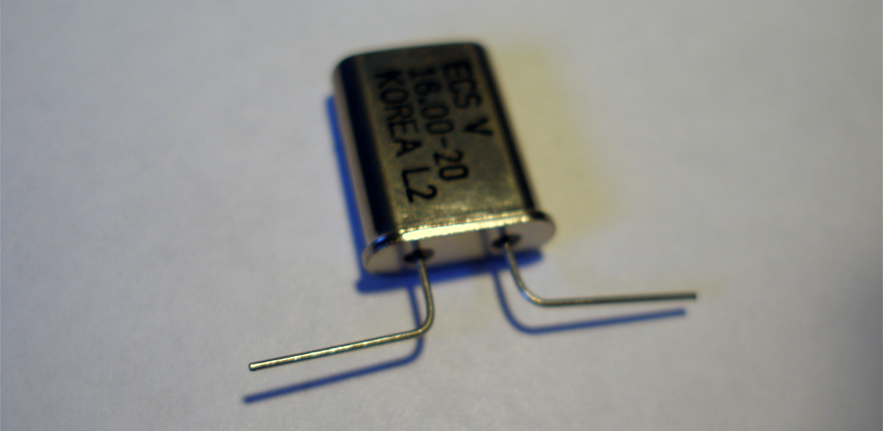
Trim off the excess lead length.
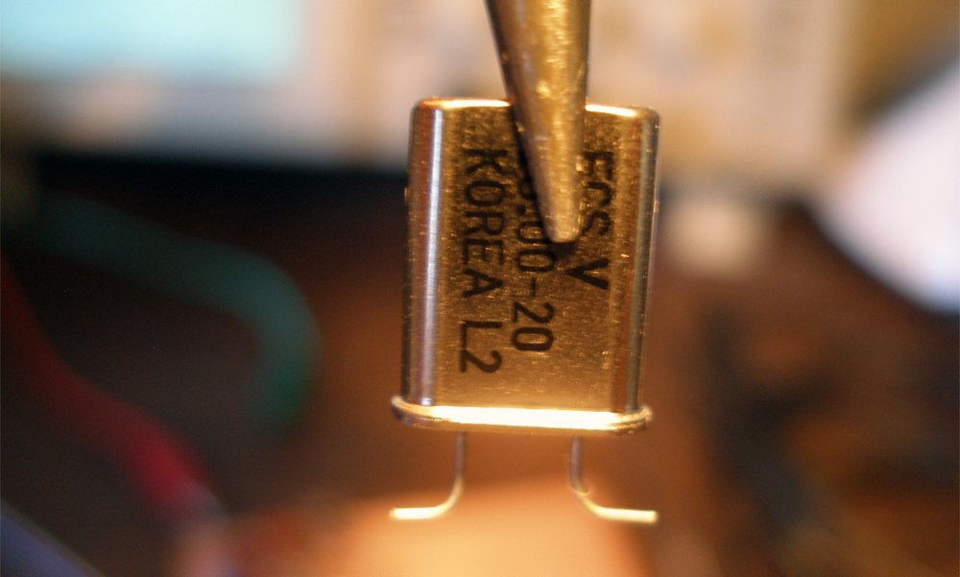

Pre-Build Procedures

Diode Matching
In order to get the best performance from our receiver mixer, we need to find a set of 1N4148 diodes with closest forward voltage characteristics. The easiest way to do this is to use the diode tester on your multimeter, if you have one. Gather together all of your 1N4148 diodes and measure forward voltage of each one with the diode tester setting. I've found an easy way to track each diode is to get a blank sheet of printer paper and poke one lead of the diode into the paper after it is tested. You can then write the forward voltage next to the diode.
If you don't have a diode tester function on your multimeter, you'll just have to improvise a little. Get a 10 kΩ resistor and a breadboard. Connect one terminal of the 10 kΩ resistor to +12 VDC. Connect the anode of the diode under test to the other terminal of the resistor. Finally, connect the cathode of the diode to ground. Apply power to the circuit, then measure and record the voltage drop across the diode with your multimeter. Repeat the process for all of the 1N4148 diodes in the kit.
Once you have measured all of the diodes, set aside four of the diodes with the closest forward voltage measurements. These will be used in the receiver mixer as diodes D7-D10. Optionally, you can also pick out the next best four diodes for the mixer in the heterodyne VFO (D2-D5).

Preparing Potentiometers and Jacks
Included in the kit is a length of ribbon cable which will be used as leads for the potentiometers and jacks used in the kit. Take your hobby knife and trim the number of conductors needed from the ribbon cable (two for jacks and three for potentiometers).
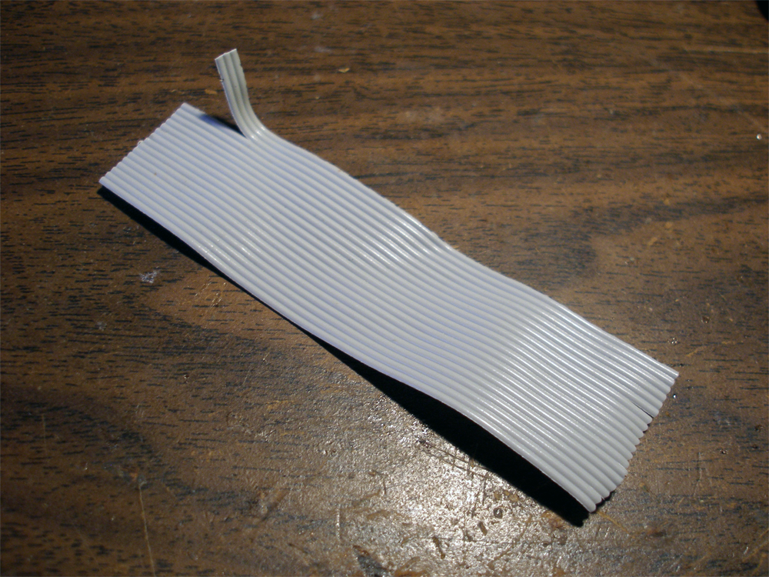
Split off about 1” of the individual conductors on each end of the cable using the hobby knife.
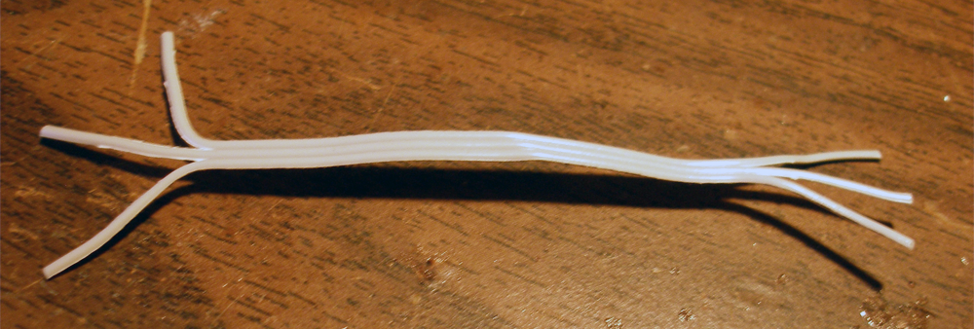
Strip and tin the individual leads, then solder one end of your cable to the device.
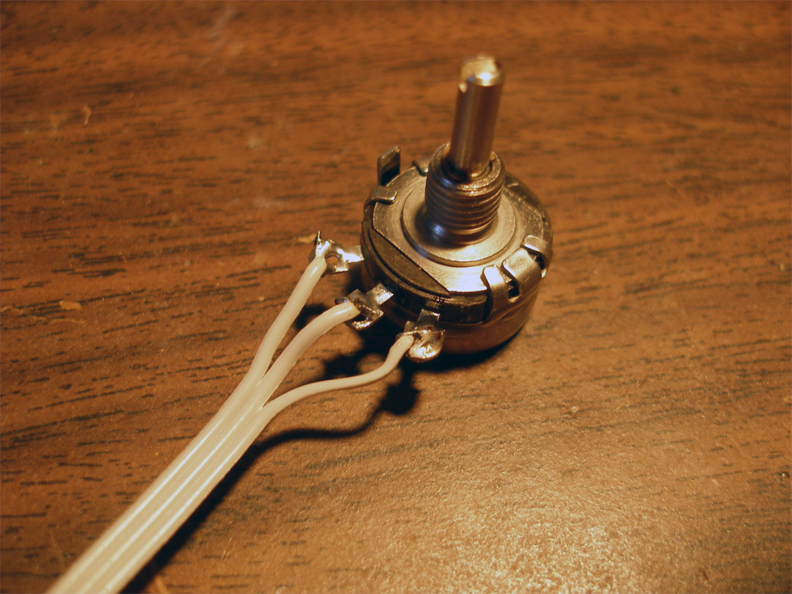

Preparing Copper Clad
When building a Manhattan circuit, you'll want to trim the copper clad substrate to the correct size before you start building. The copper clad provided with the kit will already be cut to size, so you may not need to worry about this step. If you do need to cut your copper clad, there are many different options. The ultimate way is to use a shear, but many of us don't have access to a metal shop. I've found that a good substitute is to use a pair of aviation tin snips. Just use a combination square and Sharpie to mark your cuts, and the tin snips will cut the copper clad with no problems. They may warp the material a bit, but it is easily bent back into shape.
Next you will want to clean and prepare the surface. Use a Scotch Brite pad and water to scrub both sides of the copper clad so that it is clean and free of oxidation. Be sure to handle the board by the edges so that you don't get greasy fingerprints on the board while you are cleaning or when you are done. Dry off the board with some paper towels.
Finally, the board will need to be protected from further oxidation and contamination. I like to use acrylic lacquer in a spray can for this purpose. Apply a few coats of the lacquer to one side of the board in a well ventilated area and allow it to dry for about an hour. You can then spray the other side of the board as you did the first side. It's best to allow the lacquer a good 12 hours or so to dry before working on the board, but I have been known to get impatient and start working on the board after a few hours. Be aware that if you do this, you might have some melting lacquer on your hands and workbench after you start applying the soldering iron!

Part 1 - Heterodyne VFO

Build Sequence 1

Ceramic Resonator Oscillator

Circuit Description
This is the first of two oscillators which are mixed together to produce the desired VFO output signal. The circuit is based on a voltage-tuned Clapp design followed by a common collector buffer. We also build a +8V voltage regulator in this step, which merely consists of the LM7808 voltage regulator IC and two capacitors to provide filtering.
Q1 is the active device in the oscillator, which is biased by R4, R5, R6, and R7. Capacitors C4 and C5 form a voltage divider, which provides positive feedback used to sustain the oscillation.
Ceramic resonator X1 is the main frequency determining component in this oscillator. Inductor L1 is placed in series with X1 to provide a bit of additional frequency agility. D1, a varactor, provides the main tuning for the oscillator (and the VFO). A variable voltage is applied to the cathode, which varies the capacitance of the diode junction. Tuning control R2 is a potentiometer setup as a voltage divider. R1 is configured as a rheostat to set the maximum voltage applied to D1, which sets the lower tuning limit of the oscillator. Only a small amount of current is needed to bias D1, so the tuning voltage is applied through R3. Capacitors C1, C2, and C3 are used to bypass unwanted RF signals to ground.
Buffering is used to reduce the effects of loading on the ceramic resonator oscillator. Q1 is setup as a voltage follower to provide the buffering, with R8 providing bias and setting the output impedance. R9 is used in series with the 50 Ω load to match to emitter resistor R8. Capacitor C6 provides DC blocking, while allowing the oscillator signal to pass.
- Step 1 – Install VR1
Be sure to observe the correct orientation of VR1 to ensure that the input and output terminals are placed correctly.
- Step 2 – Install C33, C34
C33 is a polarized electrolytic capacitor; make sure that it is installed with the correct orientation.
- Step 3 – Sanity Check
The +8 VDC voltage regulator is now complete. Connect a +12 VDC power supply to the VR1 input terminal (pin 3). Apply power and make sure that the voltage regulator is providing +8 VDC output at pin 1.
- Step 4 – Install Q1
- Step 5 – Install R4, R5, R6, R7
- Step 6 – Install C3, C4, C5
- Step 7 – Install Q2
- Step 8 – Jumper Q2 collector to Q1 collector
Use a clipped component lead as a small jumper to connect the two pads together.
- Step 9 – Install R8, R9
- Step 10 – Install C6
- Step 11 – Wind and install L1
L1 is a 43 uH inductor wound on a FT37-43 ferrite core. Wind 12 turns on the core and prepare the leads as specified in the Construction Methods.
- Step 12 – Install X1
- Step 13 – Install D1
Varactor diode D1 is polarized and will not work correctly if it is installed the wrong way. Be sure to install it correctly.
- Step 14 – Temporarily wire +8v Reg to R6
- Step 15 – Install R3
- Step 16 – Install C2
- Step 17 – Install R1
This potentiometer is configured to be a rheostat so that we can use it as a variable resistance. In order to do this, you can either connect one of the end terminals to the wiper, or just leave that end terminal unused. The other end terminals connects to +8v Reg, while the wiper connects to an end terminal of R2.
Once R2 is installed, set the pot to mid-range for ease in finding the oscillation frequency in a later check.
- Step 18 – Install C1
- Step 19 – Install R2
R2 is the main tuning control for the transceiver. It operates (in conjunction with R1) as a variable voltage divider to provide bias to tuning diode D1. Prepare leads for the potentiometer as described in the Construction Methods above. In order to have this control tune upwards in frequency as the knob is rotated clockwise, the terminals must be wired in the correct way. (Due to the subtractive mixing scheme we are using, tuning the ceramic resonator oscillator down in frequency will actually increase the frequency of the VFO). As the bias voltage on D1 is increased, its capacitance is decreased. Therefore, the maximum tuning voltage will correspond to the minimum end of the tuning range. This means that we want to connect the terminal on the clockwise side of the pot to R1, and the other side to ground. The wiper terminal connects to R3.
- Step 20– Temporarily wire +8v Reg to R1
- Step 21 – Sanity Check
Now that the tuning circuitry is complete, we need to verify that it operates correctly and that the tuning range is acceptable. If you have a frequency counter, connect it to output of the ceramic resonator oscillator and apply power. Otherwise, terminate the oscillator output (C6) in 50 Ω by connecting it to your dummy load or by tacking a 51 Ω resistor from the output to ground.
If you don't have access to a counter, then apply power and tune your general coverage receiver to zero-beat the oscillator note near 4 MHz. As you re-tune the oscillator during the following steps, you will have to zero beat the signal after each adjustment. You may need to tack a small piece of wire or clip a test lead to the output to use as an radiating antenna.
Set the Tune control (R2) to fully counterclockwise and note the frequency. It should be somewhere around 4.000 MHz. Turn R2 clockwise and verify that the frequency is decreasing as you tune (due to the mixing scheme in the VFO, this is the behavior we are looking for). If it increases, you probably have the terminals of R2 reversed. At the full clockwise tuning position, again take note of the frequency. You should be measuring a frequency near 3.910 MHz.
Set R2 back to fully counterclockwise, then adjust trim pot R1 and make sure that there is a small variation in frequency from one end of the dial to the other (approximately 15 kHz).
If you have an oscilloscope, connect a probe to the oscillator output and be sure that you have a stable 4 MHz waveform. The signal level should be about 750 mVpp. Note that the waveform is not a perfect sine wave. If using a RF probe, you should measure approximately 120 mV at the oscillator output.

Crystal Oscillator

Circuit Description
The output of this oscillator is mixed with the output of the ceramic resonator oscillator to provide the final VFO output on the 20 meter band. This circuit is very similar to the ceramic resonator oscillator, so we will only cover the differences between the two circuits.
Due to the high oscillation frequency of X2 and the internal capacitance of Q4, no capacitor is needed between its base and emitter to provide the necessary feedback. Therefore, only C19 is used in this oscillator.
Capacitors C16 and C18 provide capacitance to pull the frequency of the oscillator downwards a bit from its nominal frequency. Transistor Q3 acts as a switch to shunt C18 during transmit, which effectively takes it out of the circuit. This has the effect of raising the total capacitance on the crystal, which lowers the oscillation frequency further (since capacitors in series provide a smaller capacitance than either of the individual capacitors). C18 is adjustable to set the amount of frequency shift on transmit (which is usually around 600 Hz). The RIT circuit is also connected to the same node to provide an adjustable tuning offset on receive.
- Step 22 – Install Q4
- Step 23 – Install R14, R15, R16, R17
- Step 24 – Install C17, C19
- Step 25 – Install Q5
- Step 26 – Install R18, R19
- Step 27 – Jumper Q4 collector to Q5 collector
- Step 28 – Install C20
- Step 29 – Install L4
In the kit, L4 is a molded inductor, although a toroidal inductor may be substituted for those who do not have this particular component.
- Step 30 – Install X2
- Step 31 – Install C16, C18
- Step 32 – Sanity Check
The main portion of the crystal oscillator has now been completed and is ready to be checked out. Temporarily terminate the oscillator output (C20) in 50 Ω and apply power to the circuit. Verify that the circuit is oscillating near 18.000 MHz.
If you have an oscilloscope, verify that the output of the oscillator is clean and stable, with an amplitude of approximately 1.5 Vpp. Using a RF probe, you should measure approximately 680 mV at the output.
- Step 33 – Install Q3
- Step 34 – Install R13
- Step 35 – Sanity Check
The components installed in the previous two steps allows the VFO to be shifted in frequency during transmit. This is necessary in a direct conversion transceiver in order to transmit on the correct frequency during a QSO. For example, let's say that we hear an operator calling CQ and want to answer him. When we tuned into this signal, we tuned the VFO to a frequency that is 600 Hz (or so) offset from the CW carrier. This is done so that when the incoming CW is mixed with the VFO, the resulting mixing product is 600 Hz audio. The other operator is expecting a return transmission on the CW carrier frequency. If no frequency offset were used on our end, then we would end up transmitting a signal 600 Hz off of this carrier frequency, which may end up out of the other operator's receiver passband.
Connect an alligator clip or wire to the +12V rail for temporary use in switching the offset. Connect this +12V lead to the +12V T terminal of R13, which will enable Q3. If you have a frequency counter, connect it to the output of the oscillator. If using an oscilloscope or RF probe, make sure that the crystal oscillator is terminated in 50 Ω. Apply power to the oscillator and take note of the frequency. Remove the +12V T test lead and take note of the new oscillation frequency. The difference between the two frequencies is the amount of frequency shift on transmit. Most rigs use a 600 to 700 Hz offset, although you can customize this to your needs. If the transmit offset is not where you want it, adjust C18 to produce a frequency with the desired offset from the frequency measured with Q3 enabled.
If you do not have a frequency counter, you will have to use your general coverage receiver for this check (set to USB). Apply power to the oscillator, connect +12V to R13, and tune the signal for zero beat on the receiver. Remove the +12V line from R13 and listen to the CW note produced on the receiver. Adjust C18 to produce the desired CW transmit offset note. Apply +12V to R13 to make sure that the oscillator is still zero beat, then remove it one last time to make sure that you have the desired transmit offset.

RIT

Circuit Description
Receive Incremental Tuning is achieved in this VFO by paralleling a MV209 varactor with trimmer capacitor C18. During receive operation, a variable tuning voltage is applied to D6 to alter the receive frequency. This voltage is generated by a voltage divider formed by resistors R37, R39, and potentiometer R38. R40 controls the current for the bias voltage to D6. On transmit periods, MOSFET Q8 is turned on, which shunts RIT control R38. Taking R38 out of the voltage divider means that +4 V is always present on the wiper of R38 during transmit periods (the same voltage that would be there if R38 were set at its center-detent position). Capacitor C32 provides a bit of scaling for the RIT circuit, as the oscillator sees this capacitance in series with the capacitance of D6, reducing the combined value. C32 can be changed to adjust the RIT tuning range.
- Step 36 – Install C32
- Step 37 – Install D6
Varactor diode D6 is polarized and will not work correctly if it is installed the wrong way. Be sure to install it correctly.
- Step 38– Install R40
- Step 39 – Install C31
- Step 40 – Install R37, R39
- Step 41 – Install Q8
Be careful when handing Q8, it is ESD sensitive.
- Step 42 – Install R36
- Step 43 – Install R38
Center-detent potentiometer R38 controls the amount of voltage applied to tuning diode D6, which sets the RIT offset applied to the VFO. Prepare the leads for R38 as specified in the Construction Methods. The potentiometer needs to be wired as a voltage divider, so that when it is turned counterclockwise the frequency decreases, and vice versa. This means that the pot terminal on the counterclockwise end needs to be wired to R37, while the other end needs to be connected to R39. Of course, this leaves the wiper to connect to R40.
- Step 44 – Wire +8v Reg to R37
Connect a short piece of wire from the output terminal of VR1 to the appropriate R37 pad.
- Step 45 – Wire +8v Reg to R6
Connect a short piece of wire from the output terminal of VR1 to the appropriate R6 pad.
- Step 46 – Wire +8v Reg to R1
Connect a short piece of wire from the R6 pad just wired to the appropriate R1 pad.
- Step 47 – Sanity Check
Now that the RIT circuitry is complete, we need to verify that it works correctly. Connect a test lead to +12V to use in testing the RIT disable. If you have a frequency counter, connect it to the crystal oscillator output (C20). Otherwise, use a general coverage receiver to zero beat the signal as described earlier. Apply power to the oscillator and set RIT control R38 to the center-detent position, then note the output frequency. Rotate the control to the fully counterclockwise position and note the output frequency again. Finally, rotate the control to the fully clockwise position and note the output frequency. You should see a tuning range of approximately 1 kHz for each direction turned from the center-detent position.
Leave R38 set to a position off of center. Apply +12V to the open terminal ofR36 to activate the RIT disable. This should have the effect of resetting the crystal oscillator frequency to the same value that you recorded earlier when it was at it's center position.
You can also check that the RIT disable is working correctly by using your receiver and ear. Set R38 to the center position, then tune the receiver (set to LSB mode) to zero beat against the crystal oscillator output. Tune R38 counterclockwise, and you should hear a changing tone from the receiver as the control is tuned. Leave R38 set off of center, then apply +12V to R36 to activate the RIT disable. The audible tone should be gone, leaving only the sound of the zero beat to the carrier.

Build Sequence 2

Crystal Oscillator Pi-Attenuator

Circuit Description
This is a simple resistive attenuator pad which is designed to be terminated in 50 Ω on both ends. You can use simple circuit analysis to calculate the voltage drops across each resistor and determine that the circuit has an input impedance of 50 Ω. When doing this assume that you are looking into the circuit at the R20/R21 node and that the output is terminated in 50 Ω.
10 dB of attenuation was chosen in order to keep the 18 Mhz signal from overdriving the mixer, which will cause unnecessary spurious products at the output.
- Step 1 – Install R20, R21, R22

Single-Balanced Diode Mixer

Circuit Description
Mixer theory is a bit too complex to delve into when doing a quick overview of the operation of a circuit. See Experimental Methods in RF Design, pages 5.7 to 5.9 ,for an excellent review of the topic.
This mixer is singled-balance because only the LO port has a differential termination. In the standard double-balanced diode mixer, both the LO and RF ports are differential terminations. Many single-balanced mixers do not include the diodes referenced as D2 and D5 in this project. The addition of these diodes help to present a better load to the LO. Without them, LO current only flows on half of a cycle. When they are present, LO current can flow for the entire cycle.
- Step 2 – Wind and install T1
Refer to the Construction Methods to wind T1, a trifilar broadband transformer. Be very careful to keep track of your windings when installing this transformer. It would be wise to double-check for continuity on each winding before installing.
- Step 3 – Install D2, D3, D4, D5
- Step 4 – Install R10, R11, R12

Double-Tuned Circuit (Bandpass Filter)

Circuit Description
A double-tuned circuit is a bandpass filter consisting of two parallel-resonant circuits coupled with a small value capacitor. In our circuit, C9, C10, and L2 form one resonator, while C12, C13, and L3 forms the other. C11 is the coupling capacitor mentioned earlier. Since these resonators are high impedance tank circuits, we need an impedance transformation to match them to the 50 Ω termination used at filter's input and output. The series/parallel capacitor pairs C7/C8 and C14/C15 provide this transformation. See http://www.qrp.pops.net/captap.asp for a detailed look at the design of this impedance transformation network.
- Step 5 – Install C7, C8, C9, C10
- Step 6 – Wind and install L2
L2 is a 738 nH inductor wound on a T37-6 iron core. Wind 16 turns on the core and prepare the leads as specified in the Construction Methods.
- Step 7 – Install C11
- Step 8 – Wind and install L3
L3 is a 738 nH inductor wound on a T37-6 iron core. Wind 16 turns on the core and prepare the leads as specified in the Construction Methods.
- Step 9 – Install C12, C13, C14, C15

Broadband RF Amplifiers

Circuit Description
This section consists of two nearly identical broadband amplifiers. We will look at the first amplifier in the chain, but the observations will also apply to the second.
Transistor Q6 is the active element in the amplifier. It is biased by resistors R23, R24, R25, R26, and R27. Broadband bifilar transformer T2 provides a 4:1 impedance transformation (the collector sees the 50 Ω as 200 Ω) and also works as a kind of “constant current” source for the collector of Q6. The stored energy in the transformer allows the collector to swing up to twice the value of the voltage supply. C23 and R28 provides emitter degeneration, which helps to increase and stabilize amplifier gain. C22 allows some of the output energy to flow back into the input, providing negative feedback to the amplifier. This reduces the gain a bit, but it also flattens the frequency-versus-gain response of the amplifier and lowers the input impedance of the amplifier. C21 and C25 perform the simple job of DC blocking, while C24 bypasses unwanted RF energy to ground.

- Step 10 – Install C21
- Step 11 – Install Q6
- Step 12 – Install R23, R24, R25, R26
- Step 13 – Install C22, C23
- Step 14 – Install R28
- Step 15 – Wind and install T2
Refer to the Construction Methods to wind T2, a bifilar broadband transformer.
- Step 16 – Install C24, C25
- Step 17 – Install R27
- Step 18 – Temporarily wire +12v to R27
- Step 19 – Sanity Check
By this point in the build, there should be enough signal present at the output of the first broadband amplifier to measure with an oscilloscope. Terminate C25 in 50 Ω and connect an oscilloscope to the output of the amplifier. Make sure that tuning control R2 is set for the center of its frequency range (approximately 14.040 MHz). Apply power to the circuit and observe the amplitude and quality of the waveform as you adjust C9 and C13 for a peak. Once adjusted correctly, you should see a waveform near 14 MHz which measures approximately 250 mVpp.
If you do not have an oscilloscope, then you can still verify that a signal on the 20 meter band is being generated by the VFO. Attach a clip lead to C25 to act as a short antenna. Apply power to the circuit and use your general coverage receiver to tune around the lower end of the 20 meter band until you hear a strong carrier. As you adjust tune control R2, you should hear the carrier move off-frequency.
- Step 20 – Install Q7
- Step 21 – Install R29, R30, R31, R32
- Step 22 – Install C26, C27
- Step 23 – Install R34
- Step 24 – Wind and install T3
Refer to the Construction Methods to wind T3, a bifilar broadband transformer.
- Step 25 – Install C28, C29
- Step 26 – Install R33
- Step 27 – Wire +12V to R33
Connect a short piece of wire from the input terminal of VR1 to the appropriate R33 pad.
- Step 28 – Wire +12V to R27
Connect a short piece of wire from the R33 pad just wired to the appropriate R27 pad.
- Step 29 – Sanity Check
The final VFO broadband amplifier is now complete, which should bring the output signal level to somewhere near +13 dBm (before the hybrid power splitter). Terminate C29 in 50 Ω and connect an oscilloscope to the output of the amplifier. Make sure that tuning control R2 is set for the center of its frequency range (approximately 14.050 MHz). Apply power and readjust trim caps C9 and C13 for maximum output from C29. After the double-tuned circuit is adjusted, you should measure approximately 3.4 Vpp output (make sure it is no less than 2 Vpp) . The output should also be a very clean sine wave at this point. If you aren't getting the required power out, try readjusting the trim caps in the double-tuned circuit again(C9 and C13).
If you do not have an oscilloscope, use a RF probe to measure the voltage on the output of C29. You should measure at least 1.4 V at this point. If you are not seeing this minimum signal level, readjust the double-tuned circuit trim caps (C9 and C13).

Alignment and Performance Verification
- Step 30 – Set VFO Lower Limit
We need to ensure that the VFO tunes the desired range of frequencies and does not allow us to tune outside of the amateur band. Set tuning control R2 to the fully counterclockwise position (minimum frequency). Measure the VFO frequency using a frequency counter, or by tuning in the carrier on a general coverage receiver with a digital readout. Most likely, you will need to adjust this lower limit to suit your personal preferences or to comply with telecommunication laws. Adjust trim pot R1 for the desired lower frequency limit.
- Step 31 – Verify Tuning Range
Measure the final adjusted lower frequency limit and take note of it. Tune R2 to the upper frequency limit (fully clockwise) and note the output frequency. You should have a difference of approximately 80 kHz, depending on parts variations and how you constructed your VFO.
- Step 32 – Verify RIT Operation
Set RIT control R38 at the center position. Measure and note the frequency of the VFO output. Tune R38 fully clockwise and again note the VFO output frequency. Finally, tune R38 fully counterclockwise and note the VFO frequency. There should be an offset of at least 1 kHz in each direction. The offset is a bit uneven when comparing each side, due to the simple nature of the circuit, but it works well in practice.
While the RIT control is set at fully clockwise, monitor the VFO frequency. Temporarily apply +12v to R36 to disable the RIT offset. While RIT is disabled, the output frequency should be lower than the value you measured at the beginning of this step by the same amount as your transmit offset.
If you do not have a frequency counter, reset the RIT control to the center-detent position. Zero beat the VFO signal on your general coverage receiver (set to LSB mode). Now, tune the RIT control counterclockwise and note that the received carrier sound frequency increases from o Hz upwards. Leave the RIT control set so that there is an audible tone in the receiver, then temporarily apply +12v to R36. If the RIT is functioning correctly, you will hear a tone at your transmit offset frequency, regardless of where the RIT control is set.
- Step 33 – Verify Output Level
The output level of the VFO has to meet a minimum across the entire tuning range in order to drive the diode mixer in the receiver correctly. Due to the characteristics of the ceramic resonator oscillator, the output signal level is lowest at the top end of the tuning range.
Set tuning control R2 to fully clockwise to tune the VFO to its upper frequency limit. Make sure that the signal level is approximately +10 dBm or greater (2 Vpp on the oscilloscope or 750 mV on the RF probe) with a +13.8 VDC power supply. Keep your measurement device on the VFO output and tune the VFO to the lower frequency limit. Check that the signal level does not drop below the +10 dBm limit at any point in the tuning range (the signal level will change a bit as the VFO is tuned downward).
- Step 34 – Verify Signal Quality (Optional)
If you have an oscilloscope with a bandwidth of 60 MHz or greater, then you can use it to verify that the output of the VFO is relatively clean and stable. When monitoring the VFO output across a 50 Ω dummy load, you should observe a near-perfect sine wave, with no fluctuation in the amplitude artifacts on the sine wave. Any deviation from a pure sine wave indicates large harmonic content in the signal.
If you are very fortunate and have access to a spectrum analyzer or an oscilloscope which has a FFT function, check the spurious response from the VFO. The 2nd harmonic of the carrier should be no greater than -32 dBc. No other spurious products should be greater than this.
- Step 35 – Verify Frequency Stability (Optional)
If you want to verify the frequency stability of the VFO, you will need a frequency counter (resolution of at least 10 Hz), a location that is temperature stable, a clock or timer, and a method of capturing data (Microsoft Excel or OpenOffice.org Calc works great).
Setup your spreadsheet program with two column headings: Elapsed Time and Frequency. The time intervals that you enter into the Elapsed Time column are your choice, although I recommend that you measure in one minute increments for at least the first 10 minutes or so. After that, five minute increments seems to work just fine.
Connect your frequency counter to the VFO output, then apply power the circuit when you are ready. Immediately record the measured frequency in the first row (it should be “0” minutes elapsed). Start your timer or note the time that your testing started. After every interval marked on your spreadsheet, note the VFO frequency in the corresponding cell. An hour of measurement is probably enough to get a good picture of what's going on, unless there is an extreme amount of drift.
Once your data is collected, you can plot it into a nice chart to graphically visualize the behavior of your VFO. Highlight all of the data you collected, including the column headers. Start the Chart Wizard and select a XY (Scatter) chart, with lines connecting the data points. The resulting graph will show you how your VFO is drifting as time passes. You can also use other spreadsheet functions to calculate things like the maximum frequency excursion and the total amount of frequency variation over time.

Enclosure Construction
Due to LO leakage and other issues (consult chapter 8 of Experimental Methods in RF Design for the exact reasons), it is very important to operate the local oscillator of a direct conversion receiver in a RF-tight enclosure. You can find some DC designs out there where the LO is unshielded, but it's likely that the performance of the receiver will fall into the novelty category.
The instructions that follow should be generic enough that they will be useful to you regardless of which method that you use.
- Step 36 – Procure Enclosure
You have a few different options for enclosing the VFO. Perhaps the easiest, but most expensive, is to use a manufactured metal enclosure, such as one from Hammond. You could also be a bit more frugal, and creatively reuse an old enclosure that was destined for the scrap heap.
A third option is to build an enclosure from scratch using raw materials. The easiest way to do this (if you don't have a metal shop) is to fabricate your enclosure from plain double-sided copper clad. All that takes is a combination square, a pair of tin snips, and a good, hot soldering gun (100 W or so). Without getting into too much detail, the idea is to cut out two identical panels for the top and bottom, two for the sides, and two for the front and back. When you are ready to assemble the enclosure, use the high wattage soldering iron to create a generous fillet joint of solder at the 90° angles where the panels meet. If you use this method, it's best to just tack solder the top cover on, for ease of removal later.
- Step 37 – Layout and Drill Holes for Circuit Board, Potentiometers, BNC Jack, and Feedthrough Capacitors
I like to use a combination square to draw a straight pencil line on the enclosure, so the ports can be aligned. Use a center punch or similar tool to mark the locations of the holes for the potentiometers, jacks, two feedthrough capacitors, and circuit board mounting bolts. Don't forget to drill additional holes for the mounting tabs on the potentiometers.
Plan so that the mounting holes on your circuit board match the ones that you drill on the bottom of your enclosure. I have found it works best if I drill the mounting holes in the circuit board first, then use them to mark the locations on the enclosure that need to be drilled.
If you have a tap set, you can drill and prepare threaded holes for the feedthrough capacitors. If you don't have this capability, it is OK to drill holes slightly larger than the threads, and then solder the capacitors to the enclosure.
- Step 38 – Prepare Cable for BNC Jack
A small length of RG-174 is used to connect the VFO output BNC jack to the circuit board output. Strip about one inch of outer jacket off of each end of the RG-174 (be careful not to nick or damage the shield braid underneath). Fan out the braid so that it is frayed out from the dielectric material underneath. Twist together the shield braid into a single ground lead on each end of the cable. Strip about a half-inch of the dielectric from the center conductor on both ends. Solder the center conductor wire to the small cup in the center of the BNC jack, and the braid to the ground tab on the outside of the jack.
- Step 39 – Install Circuit Board
Install mounting bolts on the bottom of the enclosure; bolt head on the outside of the enclosure, threads on the inside. You can install nuts or standoffs to secure the bolts to the enclosure, although with this type of circuit construction you can also install the circuit board directly on the bottom of the enclosure with the nuts on top of the circuit board. Either method works well, depending on your preference.
- Step 40 – Install Potentiometers, BNC Jack, and Feedthrough Capacitors
This is fairly self-explanatory. Mount the controls and jacks using the supplied hardware.
The RG-174 cable to the BNC jack needs to be connected to the circuit board. Solder the center connector to the pad on the free end of C29, then solder the braid to the ground plane. The VFO schematic shows the hybrid splitter as a part of this circuit, although it is not included on this board. This is because the hybrid splitter is a logical part of the VFO, however it made more sense to place the actual components on the mainboard so that only one VFO signal cable is needed.
- Step 41 – Prepare and Install Leads for Feedthrough Capacitors
Use short lengths of solid hookup wire to connect one of the feedthrough capacitors to the +12v rail, and the other to the +12v T node on the circuit board.
- Step 42 – Prepare VFO Cable
Prepare both ends of a one foot length of RG-174 as described in Step 38. Attach the BNC plug to one end of the cable as shown by the engineering drawing for the connector. Due to the complexity of the operation, specific instructions for this step will not be given here. Please consult the manufacturer's installation instructions for details. Group builders will find this information on the NT7S website.

Part 2 - Direct Conversion Receiver

Build Sequence 3

Audio Amplifier

Circuit Description
The audio amplifier consists of three stages: a driver amplifier, a buffer amplifier, and a class-AB power amplifier. The only voltage gain developed in this amplifier chain is in the driver amplifier. The buffer and power amplifiers have no voltage gain, but do provide current gain.
The driver amplifier consists of Q18 and the assorted biasing resistors (R66-R69). It functions as a simple class-A (linear) audio amplifier, which boosts the relatively small audio signal coming in from the mute circuitry up to a level which will drive the power amplifier.
Q19 functions as a buffer amplifier for the preceding driver amplifier. It is configured as a simple voltage follower, meaning that the audio voltage which appears on the emitter of Q19 is nearly exactly the same as the voltage on the base. A buffer is used here to prevent loading on the driver amplifier from the power amplifier.
The heart of the class-AB power amplifier is complementary transistor pair Q20 and Q21. These work in push-pull configuration to control the current supplied to the load (your headphones). On positive-going excursions of the input signal, Q20 is turned on, which provides a current source to the load. On negative-going excursions of the input, Q21 is turned on, which gives the load a current sink. Resistors R72 and R73 are emitter degeneration resistors which provide protection to Q20 and Q21 from thermal runaway. Diodes D11 and D12 bias Q20 and Q21 just enough to overcome the V_{BE} drop that the input signal would have to overcome. Without these diodes, the output signal would be very distorted (look up crossover distortion for more details on this). R70 sets the idling current through D11 and D12.
- Step 1 – Install C69
- Step 2 – Install R72, R73
- Step 3 – Install Q20, Q21
Q20 and Q21 are complementary transistors (2N4401 and 2N4403), so be careful not to mix these up with the PN2222A transistors used elsewhere in the rig.
- Step 4 – Install R70, R71
- Step 5 – Install C68
- Step 6 – Install D11, D12
- Step 7 – Install Q19
- Step 8 – Install jumper from Q20 collector to Q19 collector
- Step 9 – Install Q18
- Step 10 – Install R66, R67, R68, R69
- Step 11 – Install C67
- Step 12 – Install J1
J1 is a stereo headphone jack, but it needs to be driven with each channel in parallel. Remember to jumper together the terminals for both channels before connecting the cable to the copper clad.
- Step 13 – Wire R66/R68 to Q19 collector
- Step 14 – Temporarily wire +12V to R71
- Step 15 – Sanity Check
Caution: Do not place the stereo headphones on your ears during this check. There is no audio gain control yet in place, so very loud signals could potentially be present at the output!
The final audio amplifier is now complete. In order to test its functionality, an audio oscillator of some kind is needed. If you don't already have one on the test bench, you can skip ahead and build the sidetone oscillator (either construct it on the copper clad or breadboard a temporary version).
Inject a single audio tone of approximately 600 Hz, 75 mVpp (not critical) into the input at C67. Connect a set of stereo headphones to J1 but do not put them on yet. Apply power to the audio amplifier and you should be able to hear the test tone in the headphones without putting them on. Measure the audio input voltage using a DMM set for AC voltage measurement or an oscilloscope, and take note of it. Next, measure and record the audio voltage present at the output. Calculate the voltage gain of the amplifier using the following formula:

Assuming that the amplifier has not started clipping (this should not be the case as long as you keep the input signal below 350 mVrms or 1 Vpp, which produces very loud output signal of 5 Vpp!), you should measure a voltage gain (A_{v}) of approximately 5 . If you see significantly less than this, make sure that the input is not overdriving the amplifier.

Mute Circuit

Circuit Description
The function of the mute circuit is to block all audio signals from reaching the final audio amplifier chain. In the development of the radio, I found that two elements were necessary for an effective mute: a series switch and a shunt switch. 2N7000 MOSFETs were chosen as the switches due to their very low “on” resistance and the excellent source-drain isolation when turned off.
Q16 is the series switch, while Q15 functions as the shunt switch. During normal receiver operation, Q16 is turned on, because of the bias applied to its gate through R65. Q15 is turned off because there is no voltage on the Mute control line. When the mute circuit is enabled, the +12V signal which appears on the Mute line turns on Q15, which shunts incoming AF to ground. The mute line also biases Q17 on, which acts as a signal inverter in this application. Current now flows through Q17, which brings the voltage on the gate of Q16 down to nearly 0V, which turns it off. This has the effect of “opening” the series switch, to prevent any residual signal from getting through to the audio amplifier.
- Step 16 – Install Q16
Be careful when handing Q16, it is ESD sensitive.
- Step 17 – Install R65
- Step 18 – Install Q17
- Step 19 – Install R64
- Step 20 – Install Q15
Be careful when handing Q15, it is ESD sensitive.
- Step 21 – Install C65
- Step 22 – Install R63
In order to ensure that the audio volume increases as the control is turned clockwise, install the pot terminal on the clockwise side to ground and the terminal on the counterclockwise side to C65.
- Step 23 – Wire R65 to R71 (+12V)
- Step 24 – Sanity Check
Now that the AF gain control and the mute circuit is in place, we need to verify that they work correctly. Set R63 to fully clockwise and connect the audio oscillator to the open terminal of C65. Verify that a tone is heard in the headphones (once again, do not put the headphones on your ears). Turn R63 counterclockwise and the volume in the headphones should decrease. Once you set it to a comfortable volume, you may place the headphones on your ears for the next check if you wish.
While the audio tone is still being input into the amplifier, use a test lead to apply +12V to the R64/Q15 gate junction to enable the mute circuit. The audio tone in the headphones should mute immediately, with no residual audio output. Release the +12V mute control voltage, and the audio tone should immediately be present in the headphones. When you use a jumper wire to activate the mute circuit you might hear a slight amount of popping or thumping on key up or key down, but there should not be any large, objectionable impulses.

Low-Pass Audio Filter and Preamplifiers

Circuit Description
This circuit chain consists of three major portions: a common-base preamplifier, an active low-pass audio filter, and a common-emitter preamplifier.
A common-base amplifier (Q10, C53, and biasing resistors R45, R46, R48, and R49) is used at the input of the audio chain to provide a good impedance match to the diplexer which precedes it. The input impedance of this amplifier is near 50 Ω, which is what the diplexer expects to see at its output. This amplifier is powered through an active decoupler. It consists of Q11, C54, and R47. Instead of using a passive resistor/capacitor combination (as in the other amplifier circuits in the radio), a capacitor is placed on the base of a transistor and power is taken from the emitter. The has the effect of essentially multiplying the effective capacitance of C54 by the beta of Q11. The active decoupler is used here to fight AC hum from getting into the audio chain.
Q12 and Q13 form the active elements in the low-pass audio filter. These function similarly to the op-amp active audio filters which are common, but use discrete transistors in place of the op-amps. Either type of active device works fine, as long it is configured as a voltage follower. This particular filter is a four pole design with a 3.3 kHz cutoff frequency, which provides a high-frequency roll-off of approximately 24 dB/octave. You can see the filter poles as the RC combinations R50/C55, R51/C56/C57, R54/C59, and R55/C60/C61. Pages 80-82 in Solid State Design for the Radio Amateur gives an excellent review of the design of these filters.
The final part of the circuit chain is the common-emitter amplifier formed by Q14 and its biasing components. It is a simple class-A amplifier with its emitter bypassed at audio frequencies by C66 for additional gain.
- Step 25 – Install Q14
- Step 26 – Install R58, R59, R60, R61, R62
- Step 27 – Install C63, C64, C66
- Step 28 – Wire R60 to R71 (+12V)
- Step 29 – Install Q13
- Step 30 – Install R54, R55, R56, R57
- Step 31 – Install C59, C60, C61, C62
- Step 32 – Wire R56 to R71 (+12V)
- Step 33 – Install Q12
- Step 34 – Install R50, R51, R52, R53
- Step 35 – Install C55, C56, C57, C58
- Step 36 – Wire R52 to R60 (+12V)
- Step 37 – Install Q10
- Step 38 – Install R45, R46, R48, R49
- Step 39 – Install C53
- Step 40 – Install Q11
- Step 41 – Install R47
- Step 42 – Install C54
- Step 43 – Wire Q11 emitter to R48/R49
- Step 44 – Wire Q11 collector to R52 (+12V)
- Step 45 – Install C52
- Step 46 – Sanity Check
The audio chain is now complete, and a final check needs to be made to ensure that it is working correctly. Set R63 fully counterclockwise and connect an audio oscillator to the open terminal of C52. The audio signal level injected into C52 only needs to be less than 1 mVpp to produce an audible tone, so you will want to set your oscillator output accordingly. If you are using the radio's sidetone oscillator for this test, you may want to insert additional resistance in-line with the output to reduce the output voltage. Apply power to the circuit (before placing the headphones on your ears), and slowly turn R63 clockwise until you hear the injected audio tone. The audio tone should be clean and free of distortion.
- Step 47 – Verify Audio Filter Bandwidth (Optional)
If you would like to confirm that your active audio filter is working correctly, it's relatively easy to manually measure and plot the frequency response of the audio chain. You will need an audio oscillator that you can tune to known frequencies in order to perform this check.
Connect the audio oscillator to the open terminal of C52 and set it for a low level (as you did in Step 46). Set the frequency of the audio oscillator to a low value, such as 300 Hz or so. Power up the audio chain and note that you can hear the injected audio tone in the headphones. Once you confirm that the audio amplifier is working correctly, you can leave the headphones connected as a load (if you don't mind the loud audio tones during the testing), or you may want to replace them with a load resistor of similar impedance.
Connect your oscilloscope or AC voltmeter across the load to measure the output voltage at this frequency. In order to get a good range of measurements, you will need to set your input voltage so that your output voltage is at least a few volts peak-to-peak at this frequency. You will also want to set R63 to fully clockwise to get the maximum signal level to the audio amplifier. When the input frequency starts to get higher, the voltages will get much small and harder to measure. Be warned that 2 Vpp into headphones is extremely loud, so take precautions accordingly.
Once you have a good baseline voltage measurement, you will need to pick a range of frequencies to measure, then record the audio frequency and the output voltage at each measurement. I measured up to 20 kHz, which is where my output started to get lost in the noise.
The best way to accomplish this is to use a spreadsheet program. Setup three columns: frequency, voltage, and dB. Record your measurements in the first two columns. When you are done taking measurements, you will want to create a formula in the dB column. We want to know the amount of decibels down from the signal level at the baseline frequency of 600 Hz. The formula for decibels based on voltage is:

where V_{ref} is the output voltage at your reference frequency (600 Hz in our case).
Let's assume that your V_{ref} value is in cell B5 and you are calculating the decibel ratio for the voltage measurement in cell B2. The formula to calculate the decibel ratio on OpenOffice.org is then:
=20*log(B2/$B$5; 10)
The formula used in Microsoft Excel is nearly identical:
=20*log(B2/$B$5, 10)
You can then copy this formula to all of the other cells in the dB column.
Once you have your spreadsheet set up correctly, it should look something like this:
Next, you can plot a graph of your data to get a nice Bode plot of the frequency response. You will want to select the Frequency and dB columns, then run your Chart Wizard to begin. Select an XY (Scatter) plot, and be sure that smoothed lines is selected in the wizard. Once the chart is created, right-click on the x-axis and open up the axis properties. Set the scale of the x-axis to logarithmic instead of linear. You may also want to adjust the minimum and maximum x values to create a nicer graph.
Once you are done adjusting the graph settings to your liking, you should have something like this:
This shows that the roll-off is fairly close to the ideal 24 dB/octave and that the -3 dB corner frequency is near 3.3 kHz. Within the limits of component tolerance, this frequency response looks good.

Build Sequence 4

Diplexer

Circuit Description
The purpose of the diplexer is to give a proper 50 Ω termination to all of the frequencies generated by the double-balanced diode ring mixer. As the name suggests, the diplexer provides two paths for signals leaving the mixer. L10 and C51 form a low-pass filter, which allows the desired audio products from the mixer to flow into the audio stages which follow. C50 provides a low impedance path to a 51 Ω termination (R44) for all of the unwanted higher frequencies.
- Step 1 – Install C51
- Step 2 – Wind and install L10
L10 is a 2.7 mH inductor wound on a FT50-43 ferrite core. Cut a 60 inch length of 26 ga. magnet wire and wind 85 turns on the core. Because of the large number of turns needed for this inductor, you will need to wind a second layer on top of the first layer of windings in order to get all 85 to fit. Prepare the leads as specified in the Construction Methods.
- Step 3 – Install C50
- Step 4 – Install R44

Double-Balanced Diode Ring Mixer

Circuit Description
As stated earlier, mixer theory is a bit too complex to discuss in any detail here. See Experimental Methods in RF Design, pages 5.7 to 5.9 ,for an excellent review of the topic.
This mixer is referred to as a product detector, because it converts an incoming RF signal down to baseband (audio frequencies). The mixer used here is considered double-balanced, because both the LO and RF ports have differential terminations. A double-balanced mixer has much better intermodulation distortion (IMD) characteristics than a single-balanced version, which is why it is used in this application. This helps to reduce distortion in the receiver.
- Step 5 – Install pad for T6 tap lead and jumper to C50
On the layout diagram, a small jumper is installed from the C50 pad to the pad for the T6 tap lead.
- Step 6 – Install D7, D8, D9, D10
These are the four diodes of the diode ring mixer. Use the matched set of diodes which you set aside earlier. Be sure to orient the diodes correctly.
- Step 7 – Wind and install T6 and T7
Refer to the Construction Methods to wind T6 and T7, trifilar broadband transformers.

Hybrid Power Splitter

Circuit Description
The hybrid power splitter provides a way to split the VFO signal into two paths while maintaining a proper 50 Ω termination on the VFO output. C30 and L5 provide an impedance transformation from 50 Ω to the 25 Ω input impedance of transformer T4. Since T4 is a standard 4:1 wideband transformer, this means that the output impedance (across both output terminals) is 100 Ω. The 100 Ω resistor (R35) is a precautionary measure used to absorb excess power in case one of the outputs is mismatched.
This network is sometimes called a 3 dB hybrid, since there is a little less than half of the input power available to each output port (or 3 dB down from the input).
- Step 8 – Wind and install T4
Refer to the Construction Methods to wind T4, a bifilar broadband transformer.
- Step 9 – Install R35
- Step 10 – Wind and install L5
L5 is a 284 nH inductor wound on a T37-6 ferrite core. Cut a 8 inch length of 26 ga. magnet wire and wind 10 turns on the core. Prepare the leads as specified in the Construction Methods.
- Step 11 – Install C30
- Step 12 – Install RG-174 cable to hybrid
Using the cable prepared in Build Sequence 2 - Step 42, solder the center conductor to the L5/C30 junction. Solder the braid to a nearby section of the copper clad.

Double-Tuned Circuit (Bandpass Filter)

Circuit Description
This double-tuned circuit is identical to the one used in the heterodyne VFO. It provides bandpass filtering at 14 MHz, with a 250 kHz bandwidth.
- Step 13 – Install C47, C48, C49
- Step 14 – Wind and install L9
L9 is a 738 nH inductor wound on a T37-6 ferrite core. Cut a 10 inch length of 26 ga. magnet wire and wind 16 turns on the core. Prepare the leads as specified in the Construction Methods.
- Step 15 – Install C44, C45, C46
- Step 16 – Wind and install L8
L8 is a 738 nH inductor wound on a T37-6 ferrite core. Cut a 10 inch length of 26 ga. magnet wire and wind 16 turns on the core. Prepare the leads as specified in the Construction Methods.
- Step 17 – Install C41, C42, C43

RF Preamplifier

Circuit Description
A low-noise preamplifier is used in this receiver for two primary reasons. The first is the 10 dB of gain that it gives prior to the product detector. This helps to increase the receiver noise figure on the noisier upper bands like 20 meters. The second, and perhaps more important, reason is the isolation that it provides between the mixer and the antenna port. LO energy leaking through the mixer can pass out through the antenna port, then be reflected back from an antenna mismatch. This reflected energy is a contributor to the hum that direct conversion receivers are known for. The grounded-gate amplifier used here has a reverse isolation of about 30 dB, which provides excellent protection from LO leakage.
JFET Q9 is biased using a method known as self-biasing. The gate of a N-channel JFET needs to be at a negative voltage in relation to the source. In this case, the gate is placed directly at ground. Bias current flows through the drain and source, as well as through R41 and R42. According to Ohm's Law, because of the current flow in R41, there is a voltage drop across it as well. This means that Q9's source is at a higher potential than the gate, which is the condition needed to bias the JFET correctly. L7 is used as a RF choke to keep any RF from entering the ground system. T5 is used to match the 50 Ω input impedance of the double-tuned circuit to a drain load of 1.25 kΩ, which allows for a moderate amount of gain.

- Step 18 – Wind and install T5
T5 is a broadband step-down transformer. Use 10 inches of 26 ga. magnet wire to wind a 15 turn primary. Use 3 inches of 26 ga. magnet wire to wind a 3 turn secondary. Consult the Construction Methods for instructions. Make sure that the secondary winding connects to C41/C42, while the primary winding connects to R42 and R43. The phasing is not critical in this transformer.
- Step 19 – Install C40
- Step 20 – Install R42, R43
- Step 21 – Install Q9
- Step 22 – Wind and install L7
L7 is a 2.7 μH inductor wound on a T37-6 ferrite core. Cut a 16 inch length of 26 ga. magnet wire and wind 30 turns on the core. Prepare the leads as specified in the Construction Methods.
- Step 23 – Install R41
- Step 24 – Install C39

Preselector

Circuit Description
The preselector provides a mild amount of filtering to prevent strong out-of-band signals from overdriving (and distorting) the RF preamplifier. It is nothing more than a half-wave low-pass filter with an additional capacitance placed in series with the inductor to create a series-resonant LC bandpass filter. C37 provides the variability needed to tune the circuit, while C36 is placed in parallel to bring the total capacitance up to the amount needed to resonate the LC circuit on 20 meters.
- Step 25 – Install C36, C37, C38
- Step 26 – Install C35
- Step 27 – Wind and install L6
L6 is a 2.7 μH inductor wound on a T37-6 ferrite core. Cut a 16 inch length of 26 ga. magnet wire and wind 30 turns on the core. Prepare the leads as specified in the Construction Methods.

Alignment and Performance Verification
- Step 28 – Align Bandpass Filter
Now that the receiver is complete, we need to hook up the VFO so that we can test the receiver's functionality and align the filters. Connect the coaxial cable from the hybrid splitter to the VFO output BNC jack. Using clip leads, connect +12v from the mainboard to the +12v feedthrough capacitor on the VFO. Connect headphones to J1 and connect power to the +12v rail on the mainboard. Temporarily terminate the open port of the hybrid splitter in 50 Ω.
Some kind of signal source will be needed in order to perform the alignment and check that the receiver is functioning correctly. One of the easiest signal sources to use for this purpose is the broadband noise generator documented in the Test Circuits section of the documentation. You can also use a signal generator of just about any type, as long as it can output a CW signal on 20 meters. This can range from a full-blown lab-grade signal source to a simple crystal oscillator that has been breadboarded. The final option is to connect an antenna to input to make use of band noise for the alignment.
Connect your signal source to the RX Ant terminal (junction of C35/L6). Set the volume control to mid-range, and place your headphones on. Apply power to the receiver, and listen for an increase of noise. If you are using a CW signal source, you will have to tune the VFO until you find the test signal. Otherwise, tune the VFO for an approximate mid-range setting.
Using a small tweaker (preferably non-metallic), start adjusting trim caps C43 and C47 for maximum received noise or signal. You will have to move back and forth between the two trimmers making adjustments, since they tend to have some interaction on each other. Adjust each trimmer until you cannot increase the received signal level any further.
- Step 29 – Align Preselector
Using the same setup as in the previous step, we will now align the preselector. This alignment is a simple matter of using your tweaker to adjust C37 for maximum received signal level. Once the bandpass filter and preselector is aligned, you should notice a significant increase in signal level compared to the point at which you first powered it up in an unaligned state.
- Step 30 – Verify Receiver Operation
After alignment of the bandpass filter and preselector, nothing further needs to be done to prepare the receiver for use. Connect an antenna to the RX Ant input and tune the VFO to find signals on the band. Assuming that the propagation conditions are favorable, you should now be able to receive signals off of the 20 meter amateur band. Congratulations, you now have a working receiver!
Spend some time tuning around the band to get a feel for your receiver's performance. Hopefully, you can catch some DX on the lower portion of the CW band, then maybe move up to the upper part of the band to hear some different digi-modes (sometimes it's fun to plug in a cable from your receiver phone jack to a PC sound card input to decode the digi-mode transmissions). Notice that you will hear an identical copy of each signal on either side of zero beat. You should also notice the mild level of low-pass filtering in the audio chain, which will demonstrate itself as you tune away from a CW note.

Part 3 - CW Transmitter

Build Sequence 5

Transmit Driver Amplifier

Circuit Description
The transmit driver amplifier takes the approximately
+9 dBm CW signal from the VFO and linearly amplifies it to a level of approximately +25 dBm (about 330 mW). This is the amount of drive needed to fully power the transmit power amplifier for a 5 W output.
Trimmer R74 acts as a voltage divider to provide a fully adjustable level of VFO energy to the amplifier. Q22 is voltage-divider biased by R75 and R76 to ensure that the amplifier operates in class-A mode. Q22's emitter is RF bypassed to a 12 Ω resistor (R79) through C71. A bifilar broadband transformer (T8) is used to transform the expected 50 Ω output load to a 200 Ω collector load. Note that this amplifier is powered from the +12v T line, which means that it is only turned on during key-down.
- Step 1 – Install R74
- Step 2 – Install C70
- Step 3 – Install Q22
- Step 4 – Install T8
Refer to the Construction Methods to wind T8, a bifilar broadband transformer.
- Step 5 – Install R75, R76, R77, R78, R79
- Step 6 – Install C71, C72, C73
- Step 7 – Sanity Check
Connect a temporary test lead (an alligator clip lead is probably best for this test) to the +12v rail for use in keying the transmit driver amplifier. Terminate the amplifier output (C73) with a 50 Ω dummy load. Connect the VFO to the mainboard (coax from VFO output to hybrid splitter, +12v to VFO feedthrough capacitor). Set R74 to fully clockwise to get the maximum amount of VFO drive signal into the amplifier input. Connect the +12v rail to a power supply, and turn on power.
Connect the temporary +12v test lead to the +12v T node on R78. Measure the power output at the dummy load using an oscilloscope, RF probe, or milliwatt meter (if using a milliwatt meter, it may have a built-in 50 Ω termination). You should measure approximately 10 to 11 Vpp using the oscilloscope. Also note that the waveform is not very clean (due to the impedance mismatch of R74 and the hybrid splitter). If using the RF probe, you should measure approximately 2.5 to 2.8 V on your voltmeter. If your output is connected to a milliwatt meter, you should read approximately 250 to 330 mW of output power.
While monitoring the output power, adjust R74 counterclockwise and note that the output smoothly adjusts down to nearly zero. Turn R74 back to fully clockwise and check that the power smoothly ramps back up to the value measured previously.

Transmit Power Amplifier

Circuit Description
During periods of key-down, the transmit driver amplifier generates a CW signal of approximately +25 dBm (330 mW), which is then amplified by the class-C transmit power amplifier to a level of about +37 dBm (5 W).
Transformer T9 provides a 4:1 impedance transformation to match the 50 Ω output of the transmit driver amplifier to an impedance of 12.5 Ω, which is needed to drive the base of Q23 properly. In order to get a power output of 5 W, the collector needs to see a load of :

Since we desire a 5 W power output:

We can come close to this by using a 1:4 broadband transformer (T10) to transform the standard 50 Ω output impedance to a 12.5 Ω load for Q23's collector.
- Step 8 – Wind and install T9
Refer to the Construction Methods to wind T9, a bifilar broadband transformer.
- Step 9 – Install C74
- Step 10 – Install R80
- Step 11 – Install Q23
Secure Q23 to the copper clad substrate using a 4-40 bolt (approximately ¼ inch) and nut.
- Step 12 – Wind and install T10
Refer to the Construction Methods to wind T10, a bifilar broadband transformer wound on a binocular core (BN43-302).
- Step 13 – Install C75, C76, C78
- Step 14 – Wire T10 to R71 (+12v)

Transmit Low-Pass Filter

Circuit Description
This low-pass filter is a standardized three-pole, half-wave design taken directly from the W1FB QRP Notebook. Since the Transmit Power Amplifier operates in class-C mode, the output waveform will be heavily distorted and have much harmonic content. The purpose of this filter is to greatly reduce the harmonics of the signal, which will result in a clean sine wave output at the antenna port when operating into a 50 Ω resistive load.
- Step 15 – Install C79
- Step 16 – Wind and install L12
L12 is a 738 nH inductor wound on a T37-6 ferrite core. Cut a 9 inch length of 26 ga. magnet wire and wind 16 turns on the core. Prepare the leads as specified in the Construction Methods.
- Step 17 – Install C80
- Step 18 – Wind and install L13
L13 is a 866 nH inductor wound on a T37-6 ferrite core. Cut a 10 inch length of 26 ga. magnet wire and wind 17 turns on the core. Prepare the leads as specified in the Construction Methods.
- Step 19 – Install C81
- Step 20 – Wind and install L14
L14 is a 738 nH inductor wound on a T37-6 ferrite core. Cut a 9 inch length of 26 ga. magnet wire and wind 16 turns on the core. Prepare the leads as specified in the Construction Methods.
- Step 21 – Install C82
- Step 22 – Install antenna connector J2 to C82
This is a user-supplied connector. Use your own preferred antenna jack (BNC, UHF, etc.) using a small piece of RG-174 coaxial cable.

T/R Switch

Circuit Description
This circuit is not so much a switch as it is a filter. L11 and C77 form a 14 MHz series-resonant LC circuit. During periods of receiving, the incoming RF is picked off after the 14 MHz low-pass filter. It passes through the T/R switch circuitry with very little attenuation, since the L11/C77 is resonant at this frequency range. From there it is fed into the front end of the receiver.
During periods of transmit, the 14 MHz component of the output of the PA (remember that there are also lots of harmonics present at this point) can pass through L11/C77. However, because this is such a large signal, the waveform will be clipped by D13-D16. This will only allow a maximum signal level of about 2.4 Vpp to pass to the receiver front end, which is low enough to protect it from damage. Since the audio chain is also muted during transmit, your ears are protected from the very large audio signal this would generate.
- Step 23 – Install C77
- Step 24 – Install D13, D14, D15, D16
- Step 25 – Wind and install L11
L11 is a 5.68 μH inductor wound on a T50-2 ferrite core. Cut a 22 inch length of 26 ga. magnet wire and wind 34 turns on the core. Prepare the leads as specified in the Construction Methods.

Alignment and Performance Verification
- Step 26 – Verify Power Output
Connect a temporary test lead to +12v for keying (as described in Step 7). Connect a 50 Ω dummy load to the antenna jack J2 (If you have a power meter with a built-in load, connect this to J2). Connect the +12v rail to a power supply, and turn on power. Make sure that your headphones are not connected to J1 during this test.
Apply the +12v test lead to the +12v T node of R78 in order to key the transmitter (be careful to key down for only enough time to make a measurement). Measure the power output at the dummy load using an oscilloscope or power meter. You cannot use the RF probe for this measurement because the 5 W output power nearly exceeds the PIV rating of a 1N34A diode. If using an oscilloscope, you should measure a signal of approximately 50 Vpp with a very clean sine waveform. If using a power meter, you should measure approximately 5 W of output power.
While keying the transmitter, adjust R74 counterclockwise and observe that the power output is continuously adjustable down to nearly 0 W. Readjust R74 back to fully clockwise, and observe that the power output smoothly adjusts back up to the maximum output of approximately 5 W.
- Step 27 – Verify Signal Purity (Optional)
If you are fortunate enough to own an oscilloscope with a FFT function or a spectrum analyzer, use it to measure the spurious output of the transmitter into a 50 Ω resistive load. If your oscilloscope does not have a FFT function, you can still roughly verify signal purity by observing that the output waveform is very close to a perfect sine wave.
Due to the wide variations in instruments, I cannot provide detailed instructions on how to setup your particular test equipment for this measurement. Please consult your product manual for this information.
To illustrate an example, I tested the beta rig using a Tektronix TDS1012 DSO, which has a FFT function. The following illustration is a screen shot of the FFT display, showing that there are no spurious products greater than -43 dBc (decibels below the carrier). This meets the FCC specifications for spurious emissions (§97.307), which states that the maximum spurious level allowed in a HF transmitter is -43 dBc.
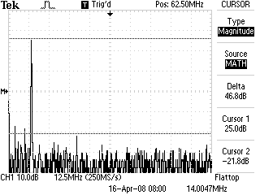
The next illustration is the same FFT measurement, but with the frequency cursors turned on. This shows that the carrier is at 14.00 MHz and that the large spur present above the carrier is the 3rd harmonic at 42.00 MHz.
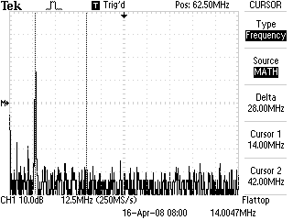
A spectrum analyzer display should be fairly similar to this, but should provide even better accuracy and measurement capabilities.

Part 4 - Support Circuitry/Integration

Build Sequence 6

Keying Circuit

Circuit Description
There are two separate keying circuits controlled by one key line. Diodes D17 and D18 prevent any current from inadvertently flowing into the circuits during periods of switching or if there are any failures of the key line. Both PNP transistors Q24 and Q25 are turned on by grounding their bases through the respective diodes. This allows current to flow from the emitter to the collector, which then provides a positive voltage to the respective circuits that they supply.
Two separate circuits are used to give two different keying responses based on one key line. Q24 is the switch which controls the bias on the transmit driver amplifier, switches in the VFO transmit offset, and turns on the sidetone. C83 is placed across the base and collector to give the keying a bit of shaping, which helps to reduce key clicks.
Q25 controls the audio mute switch. When Q25 is activated, current flows through D19, allowing C84 to charge very quickly. This activates the Mute line before the transmitter fully turns on. After the key line is released and current stops flowing through Q25, C84 discharges through R85. This results in a gentle ramp down of the voltage on the Mute line. The fall time is approximately 250 ms, which gives the mute circuit a little bit of time to stay enabled while the transmitter is turned off.
- Step 1 – Install Q25
- Step 2 – Install R85
- Step 3 – Install D19
- Step 4 – Install C84
- Step 5 – Install R82, R84
- Step 6 – Install D18
- Step 7 – Wire Q25 emitter to R60
- Step 8 – Install Q24
- Step 9 – Install R81, R83
- Step 10 – Install C83
- Step 11 – Install D17
- Step 12 – Install J3
- Step 13 – Wire +12v T from Q24 collector to R78

Twin-T Sidetone Oscillator

Circuit Description
A twin-T audio oscillator is a simple device, but it generates a pleasing audio tone that is nearly sinusoidal. Two feedback paths are inserted between the collector and base of Q26 (the negative feedback path, oddly enough). One path is a low-pass filter (R86, C86/C87, and R89) while the other is a high-pass filter (C85, R88, C88). The two of these in parallel essentially functions as a notch filter, which virtually eliminates the desired oscillation frequency from the negative feedback path. This has the effect of suppressing energy at all frequencies except for the desired oscillation frequency.
- Step 14 – Install R87
- Step 15 – Install C85, C88
- Step 16 – Install R88
- Step 17 – Install Q26
- Step 18 – Install R86, R89
- Step 19 – Install C86, C87
- Step 20 – Wire C85 to Q26 base
- Step 21 – Install R90
- Step 22 – Install C89
- Step 23 – Wire C89 to R86/R89
- Step 24 – Wire Q24 collector to R78

Transceiver Integration
- Step 25 – Wire +12v to VFO
- Step 26 – Wire +12v T to VFO
- Step 27 – Wire +12v DC connector to R71
- Step 28 – Connect coax cable to VFO

Final Checks
- Step 29 – Verify proper operation of receiver
Hook up the rig for operation by connecting DC power, headphones, and a key. In order to perform one final check of the receiver alignment, connect the antenna jack to the signal source of your choice (broadband noise generator, signal generator, or antenna). Supply power to the transceiver and re-peak the receiver bandpass filter and preselector, as described in Build Sequence 4 – Steps 28 & 29.
Once you are satisfied with the alignment, connect an antenna to the antenna jack to listen to live signals on the band (if possible). Verify that the audio sounds clean and that the receiver tunes correctly.
- Step 30 – Verify proper operation of transmitter
Connect a dummy load or power meter to the antenna jack and set R74 to fully clockwise. Disconnect the headphones for now. Key the transmitter and ensure that your power output is approximately 5 W.
Next, we need to double-check that the transmit offset is working correctly. Perform the check as described in Build Sequence 1 – Step 35, with the exception that you will now use your key to activate the transmitter instead of a test lead.
- Step 31 – Verify proper operation of mute and sidetone circuits
Reconnect your headphones, but do not place them on your ears yet. Key the transmitter and ensure that you can hear a clean sidetone at approximately 600 Hz. If you find that the sidetone volume is too loud for your tastes, you can adjust the value of R90 to add more attenuation.
Once you have a comfortable sidetone level, place the headphones on and key the transmitter again briefly. You should only hear the sidetone during transmit. Once the key is released, you should hear the mute continue for about ½ second before releasing.
- Step 32 – Enjoy your new transceiver!
Your new QRP transceiver is now completed and aligned. Get on the air and make your first QSO! See the Operation Quick Guide for some hints on using a direct conversion transceiver.

Operation Quick Guide
When responding to a calling station, you will want to tune the VFO downwards in frequency when tuning for a 600 Hz zero beat. Since the TX offset shifts the VFO frequency down 600 Hz on transmit, this will ensure that you are zero beat when you call. If you were to tune upwards in frequency to a 600 Hz note, your transmitter signal would be 1200 Hz off zero beat. Chances are good that the other station won't hear you unless they are using a wide filter.
Calling CQ is much easier. Any station that calls you will have to zero beat to you, and should know how to do so correctly.

Mods and Extensions

Band Changes
The Willamette is designed to allow it to be able to operate on nearly any HF band with some changes to the frequency sensitive circuits. If you would like to build the rig for a different frequency or modify your current rig, what follows is a list of the changes you will need to make. Keep in mind that this is an overview of the necessary changes. I won't give detailed instructions on how to implement every mod that you will need, but I will accurately document every circuit that needs to be changed. There are many resources to help you adapt circuits to the proper frequencies. The two best are probably The ARRL Handbook and Experimental Methods in RF Design.

Ceramic Resonator Oscillator
In order to move the VFO to a different band, both the ceramic resonator oscillator and crystal oscillator may need to be modified. The Willamette heterodyne VFO schematic sheet gives some possible ceramic resonator/crystal oscillator combinations. Keep in mind that many of these haven't been tested but should work well. The key thing to remember is that you should choose a ceramic resonator with a low frequency. Once you start to get much above a 4 MHz resonator, the frequency stability of the oscillator suffers.
If you restrict your choices of ceramic resonators to between 2 to 4 MHz, there there shouldn't be much else that you will have to change. Due to component variations, you may have to experiment with the values of the voltage divider capacitors C4 and C5 in order to get a different resonator to oscillate. Unfortunately, there are no hard and fast rules for these values, but you probably won't need to stray too far from the original values.

Crystal Oscillator
Unlike the ceramic resonator oscillator, it is possible to have a wide range of crystal frequencies in this oscillator in order to mix to the proper band. As with the ceramic resonator oscillator, the biggest concern when changing frequencies are the feedback capacitors in the Colpitts configuration. When using higher frequency crystals (like the 18.000 MHz crystal in the original), no feedback capacitor from the base of Q4 to the emitter may be necessary. However, if using a lower frequency crystal, there is a possibility that you will need to add a NP0 feedback capacitor to get the circuit to oscillate. Of course, you will also have to experiment with the value of C19.
Another area you will have to check is the TX offset and RIT circuitry. To correct the TX offset, change the value of C16. If using a lower frequency crystal, C16 will need to be increased in value. Likewise, if using a higher frequency crystal, try changing C16 to a lower value of capacitance. C32 controls the scaling factor of the RIT. If you aren't happy with the RIT range, then try changing this capacitor.

Bandpass Filters
There are two identical double-tuned circuit bandpass filters used in the Willamette. The first one is used in the heterodyne VFO to strip out unwanted VFO mixing products. The second is used in the receiver front end to remove strong unwanted out-of-band signals.
Designing a double-tuned circuit for other bands is outside of the scope of this documentation, but there are plenty of resources out there that will guide you through the design, even if you don't have any design experience. One of the best resources is Experimental Methods in RF Design. Page 3.14 gives the calculations necessary to design your own, as well as a pre-generated table of component values (Table 3A). You should be able to use Table 3A to satisfy your design needs. In addition, you can also use the great DTC program that is included on the EMRFD CD. You can also consult the Filter chapter in The ARRL Handbook for DTC design information. If you choose to design your own filter from calculations or a software tool, be sure that you design it for 50 Ω end terminations.

VFO Output
The output of the VFO is split into two 50 Ω terminations by using a 3 dB hybrid splitter (T4 and R35). The input impedance of this splitter is 25 Ω, meanwhile the output impedance of the amplifier preceding it is 50 Ω. Therefore, some kind of impedance matching is needed, which is the purpose of the L-network formed by C30 and L5. This L-network is frequency dependent, so you will need to change its values to adapt the VFO to different bands. Once again, the best resources for L-network design are EMRFD and The ARRL Handbook. The math is fairly simple to do, and it's not necessary to use a computer tool to perform the calculations. If you have EMRFD, consult page 3.30 and look at Figure 3.65 and the corresponding equations 3.30, 3.31, and 3.32. The Handbook has the same design information, but the location of it varies each year.
My recommendation is you select a convenient value for C30, calculate the X_{C} of this cap, then solve for the unknown value of X_{L}. Once you have X_{L}, calculate the corresponding inductance at your frequency of choice. Now, use a tool such as the inductance calculator at toroids.info to determine how to wind a toroid for this inductance.

Preselector
The preselector is a basic pi-network low-pass filter with an additional series capacitance element to provide a single-tuned circuit for a bandpass filtering. The basic design strategy here is to calculate the values for a pi-network (with 50 Ω terminations) with a cutoff at least a few megahertz above your frequency of operation. Then select a series capacitance that will provide resonance on the band of your choice with the inductor that was just calculated.
There are lots of places to learn about low-pass filter design. As always, EMRFD (section 3.2) or The ARRL Handbook are great resources. There are also computer programs that will crunch the numbers for you, such as that provided with EMRFD or the AADE filter software. Once you have your low-pass design, it's a simple matter of using the old LC resonance formula to find the amount of capacitance required:

You may not have a trimmer capacitor that will cover the necessary capacitance. In that case, you can copy the design of the Willamette and parallel some capacitance to bring it up to the required value.

Transmit Low-Pass Filter
The design of this filter was taken from a table of standardized values in the W1FB QRP Notebook, so there is nothing special about it. You can consult this book, or many others for tables that will give you the appropriate component values for your band of choice. If you want to do the calculations on your own, consult EMRFD or The ARRL Handbook.

T/R Switch
The T/R switch is simply a series resonant circuit with X_{L} and X_{C} values of 500 Ω. Recalculate the values of L11 and C77 based on your frequency of choice.

Restricting the Tuning Range
You may need to restrict the tuning range of the VFO due to license restrictions or because of band changes. Since the variable capacitance in the ceramic resonator oscillator is controlled by a voltage, restricting the voltage applied to D1 will restrict the tuning range.
Note that the following description applies to a VFO that uses the difference frequency between the ceramic resonator and crystal oscillators. If using the sum frequency, then the voltage limits on D1 will have the opposite effect.
In order to restrict the upper tuning range, some resistance will need to be added between the connection to the ground end of R2. Unmodified, the tuning circuit will go all the way down to 0 V applied to D1. By adding in resistance from R2 to ground, the voltage divider formed by R1, R2, and the new resistor never allows the voltage applied to D1 to reach 0. Hence, the amount of capacitance is restricted, which restricts the tuning range.
As the circuit stands, trimmer R1 allows some adjustment to the lower frequency range. If you find that you need to bring up the lower frequency limit even further, you have two options. You can either change R1 to a larger value or you can place more resistance between R1 and R2. It may take a bit of experimenting to find the best method, but either will work.

Audio Filtering
The default configuration of the audio filtering is quite wide open. Many operators may prefer a tighter filtering for CW listening. It's relatively simple to reconfigure the low-pass audio filtering to give the response a peak near 600 Hz and a much lower corner frequency. Here are the substitutions to make in order to change the filter response:
- Replace R50, R51, R54, and R55 with 24 kΩ
- Replace C55, C59 with 100 nF
- Remove C56, C57 then place a 1 nF capacitor from Q12 base to ground (in the place where C56 was located)
- Remove C60, C61 then place a 1 nF capacitor from Q13 base to ground (in the place where C60 was located)
This will give a sharper response that will sound noticeably different on-the-air. The graph of the filter response of the mod installed in the beta rig is shown below.

Double-Balanced Mixer
The mixers in the Willamette use garden-variety silicon 1N4148 diodes. These diodes are fine for mixer use in HF rigs, although it is easy to upgrade to Schottky diodes, which will reduce the amount of harmonic energy generated by the mixer, as well as reduce the conversion loss a bit. A 1N5711 would make a fine substitute. It comes in a similar package and is relatively inexpensive.

Test Circuits

RF Probe
This probe is a simple diode detector circuit which plugs into a digital multimeter via banana plugs. It will provide a DC voltage based on the the level of RF energy at the probe tip. The probe is most accurate with sinusoidal signals. Other types of signals will give less accurate measurements. It is assumed that the DMM has a ~10 MΩ input impedance, which nearly all of them do. A sewing needle (or something similar) can be used as a probe tip. Keep the lead lengths from the probe tip to D1 very short.
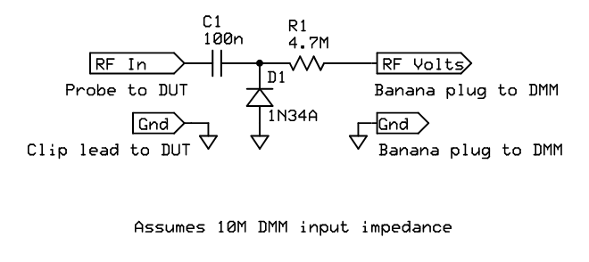

Twin-T Audio Oscillator
The Twin-T sidetone oscillator from the rig can be built before the rest of the receiver in order to use it for testing, or a separate version can be built on its own circuit board. When it is wired correctly, the circuit is nearly foolproof and provides plenty of signal level for testing the audio chain. If you build it separately, you might want to tack a simple emitter follower buffer on to the output to ensure a strong signal level wherever you inject it. It might also be useful to add a potentiometer gain control on the output.

Broadband Noise Generator
A broadband noise source based on a zener diode is very easy and cheap to make, and is invaluable for testing. The following schematic shows a noise generator that was derived from a noise bridge. A large supply of surplus 1N751A zeners were on hand, so the circuit was modified to use these. If you have a different type, feel free to substitute it, just be sure to change R1 to the appropriate value.
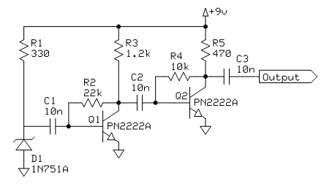

Credits
Special thanks to WB8ICN and KB9BVN for donating parts for the group build, NA5N for being an incredible Elmer, W9JDH for beta testing the design, N1RX for help with a tricky VFO mod, and W8BH for catching documentation errors. Many thanks are due to the people on qrp-l.org and the QRP-ARCI Board for their wonderful support.

Legal
This work is licensed under the Creative Commons Attribution-Noncommercial-Share Alike 3.0 United States License. To view a copy of this license, visit http://creativecommons.org/licenses/by-nc-sa/3.0/us/ or send a letter to Creative Commons, 171 Second Street, Suite 300, San Francisco, California, 94105, USA.

Bill of Materials
C1, C2, C3, C6, C17, C20, C21, C22, C23, C24, C25, C26, C27, C28, C29, C31, C34, C39, C40, C70, C71, C72, C73, C74, C75, C78, C85, C86, C87, C88, C89 100n (marked 104)
C4 470 NP0 (marked 471)
C35, C38 470 (marked 471)
C5 270 NP0 (marked 271)
C7, C14, C41, C48 18
C8, C15, C36, C42, C49, C77 22
C9, C13, C18, C37, C43, C47 45 trimmer
C10, C12, C44, C46 100 (marked 101)
C11, C45 2.2
C16 15 NP0
C19 33 NP0
C30 220 (marked 221)
C32 47 NP0
C33, C50, C51, C84 1u
C52, C66, C69 220u
C53, C54 22u
C55, C56, C57, C59, C60, C61, C76, C83 10n (marked 103)
C58, C62, C63, C64, C65, C67 10u
C68 100u
C79, C82 180 (marked 181) (50 WVDC)
C80, C81 390 (marked 391) (50 WVDC)
C90, C91 1n Feedthrough (not on schematics)
D1, D6 MV209
D2, D3, D4, D5, D7, D8, D9, D10, D11, D12, D13, D14, D15, D16, D17, D18, D19 1N4148
J1 Phones
J2 Antenna
J3 Key
L1 FT37-43 12T 43u
L2, L3, L8, L9, L12, L14 T37-6 16T 738n
L4 5.6u molded
L5 T37-6 10T 284n
L6, L7 T37-6 30T 2.7u
L10 FT50-43 85T 2.7m
L11 T50-2 34T 5.68u
L13 T37-6 17T 866n
Q1, Q2, Q3, Q4, Q5, Q6, Q7, Q10, Q11, Q12, Q13, Q14, Q17, Q18, Q19, Q26 PN2222A
Q8, Q15, Q16 2N7000
Q9 J310
Q20 2N4401
Q21, Q24, Q25 2N4403
Q22 2N5109
Q23 2SC5739
R1 5k trim pot
R2 10k linear taper pot
R3, R13, R36, R40, R47, R64,
R65, R90 100k (brown-black-yellow)
R4, R14, R48, R49, R68, R83, R84 10k (brown-black-orange)
R5, R15, R50, R51, R53, R54,
R55, R57 4.7k (yellow-violet-red)
R6, R8, R16, R18, R20, R22, R27, R33, R35, R37, R39, R41, R42, R43, R52, R56, R60, R71 100 (brown-black-brown)
R7, R17, R70 470 (yellow-violet-brown)
R9, R19, R44 51 (green-brown-black)
R10, R12, R62 300 (orange-black-brown)
R11, R80 18 (brown-gray-black)
R21 68 (blue-gray-black)
R23, R69 1.5k (brown-green-red)
R24, R25, R30, R46, R75, R81, R82 2.2k (red-red-red)
R26, R32, R85 220 (red-red-brown)
R28 4.7 (yellow-violet-gold)
R29, R31 1k (brown-black-red)
R34 10 (brown-black-black)
R38 10k center detent pot
R45, R86, R89 3.3k (orange-orange-red)
R58 47k (yellow-violet-orange)
R59 5.6k (green-blue-red)
R61, R87 3k (orange-black-red)
R63 10k audio taper pot
R66 150k (brown-green-yellow)
R67 22k (red-red-orange)
R72, R73 1 (brown-black-gold)
R74 200 trim pot
R76 680 (blue-gray-brown)
R77 33 (orange-orange-black)
R78 47 (yellow-violet-black)
R79 12 (brown-red-black)
R80 18 (brown-gray-black)
R88 560 (green-blue-brown)
T1, T6, T7 FT37-43 10T trifilar
T2, T3, T4, T8, T9 FT37-43 10T bifilar
T5 FT37-43 15T:3T
T10 BN43-302 5T bifilar
VR1 78L08
X1 4.000 MHz ceramic resonator
X2 18.000 MHz crystal

